**Databases:**

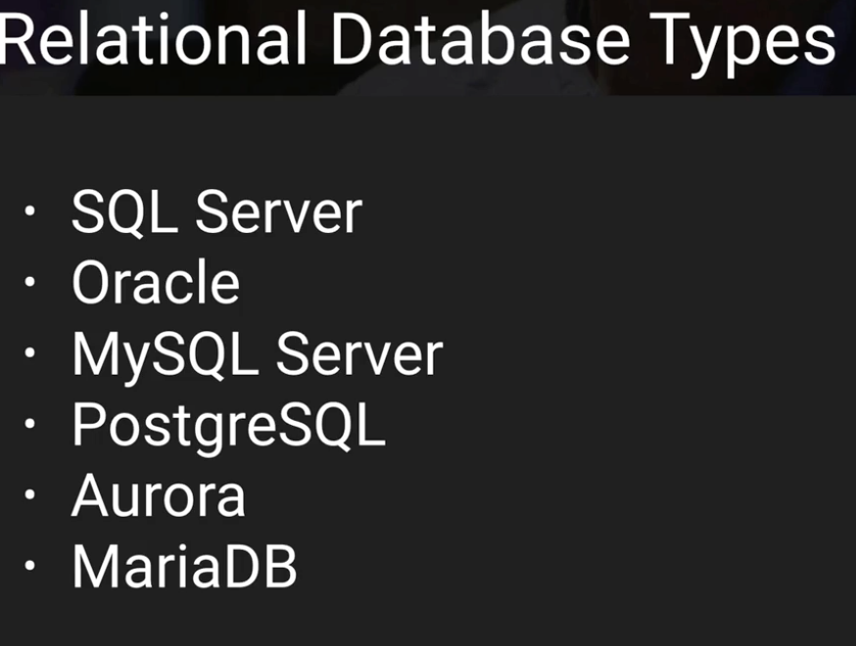

JSON <-> NoSQL

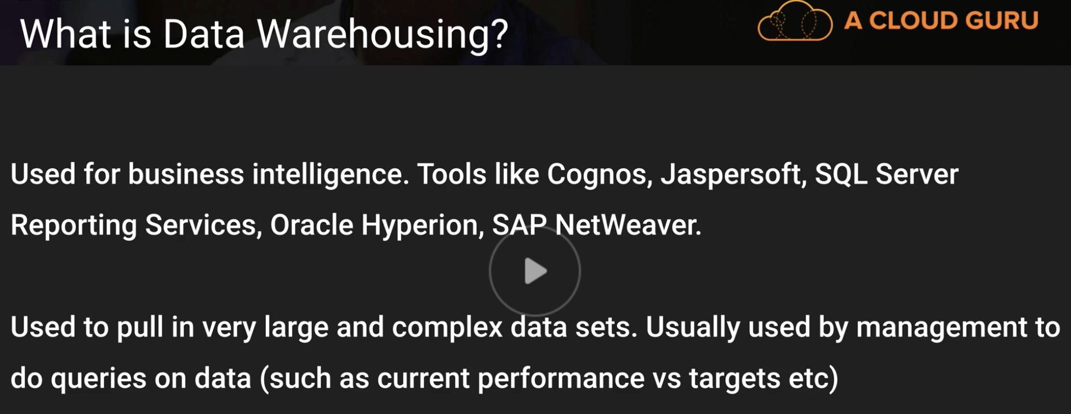

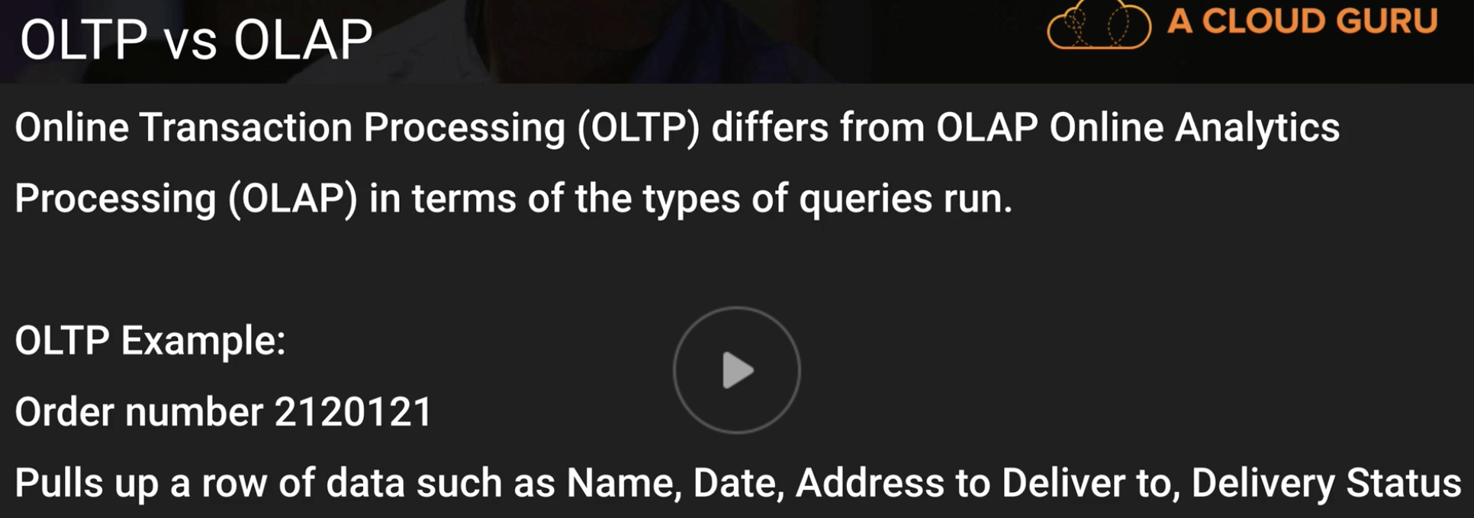

OLAP -

OLTP -

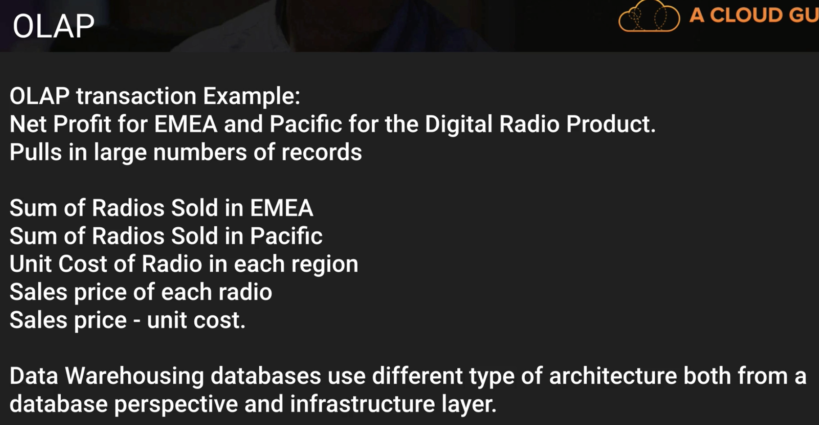

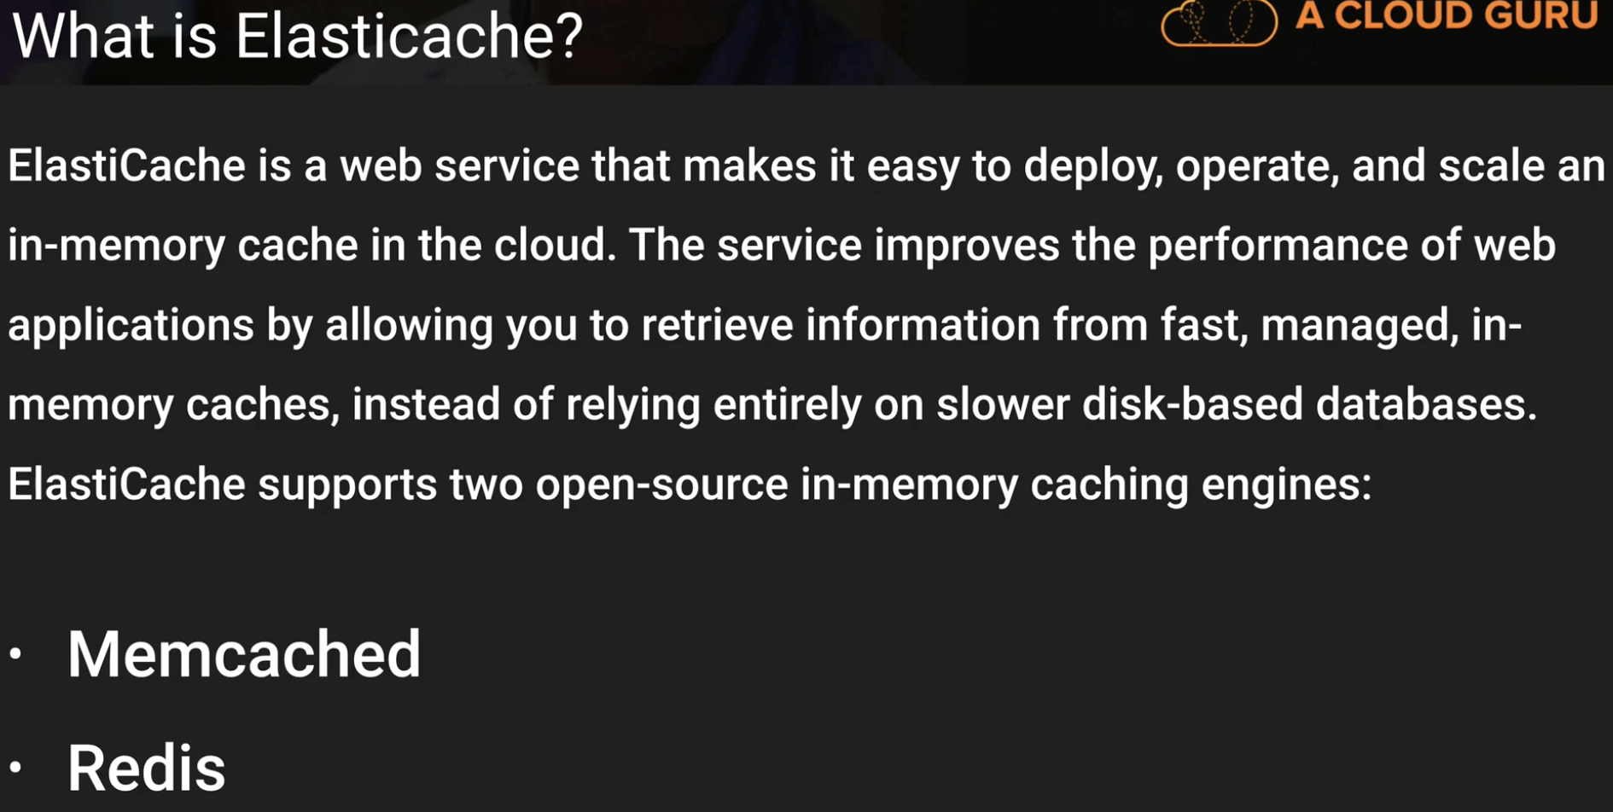

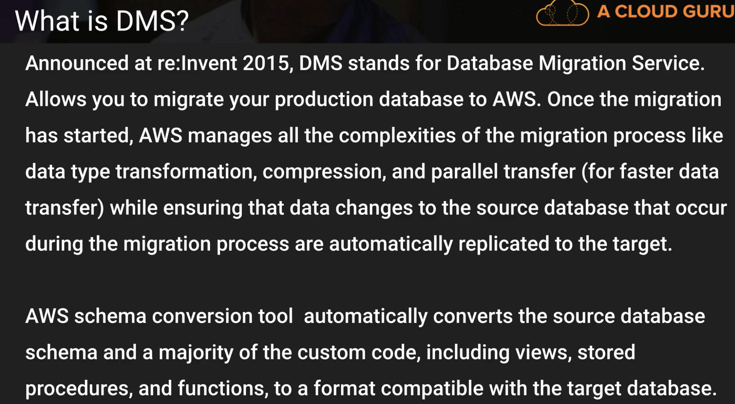

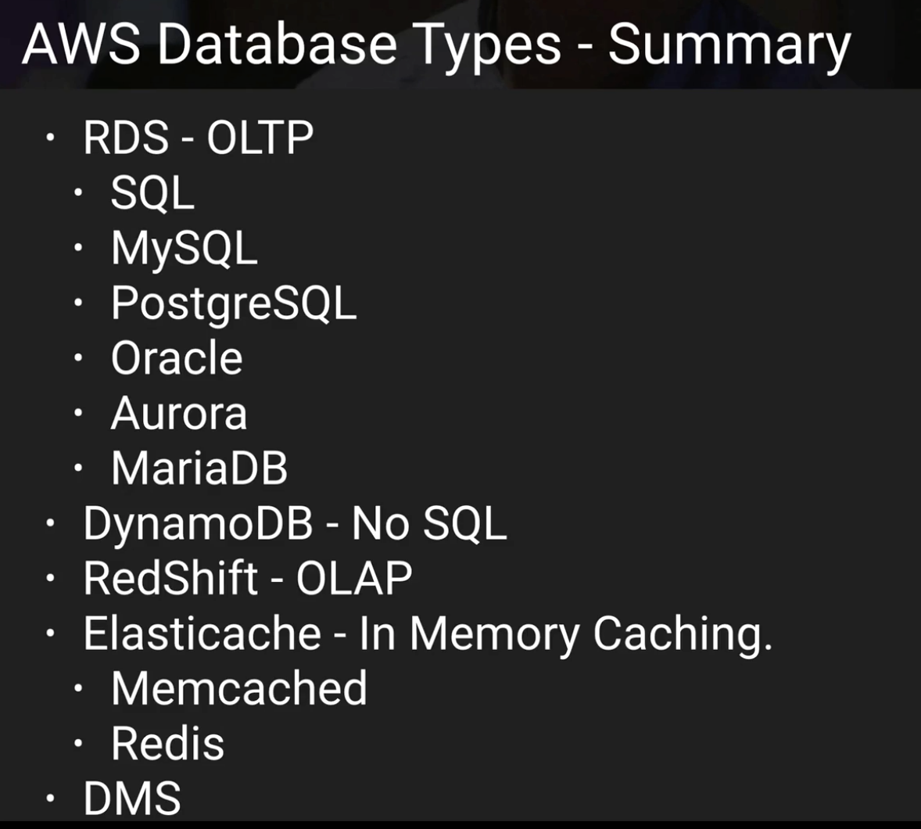

**DYNAMO DB:**

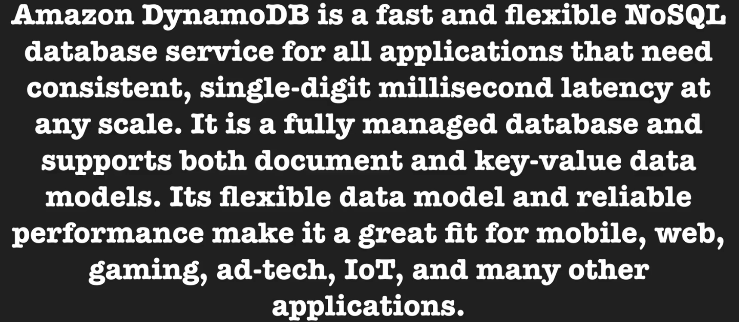

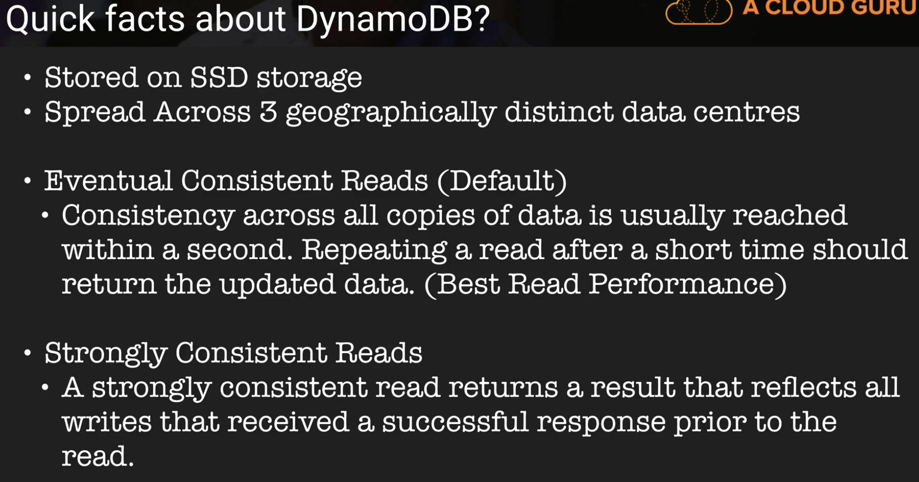

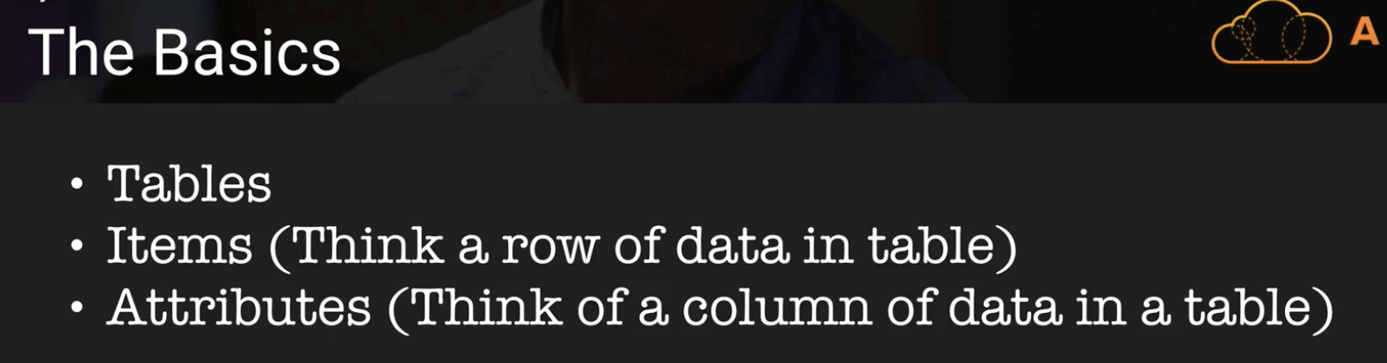

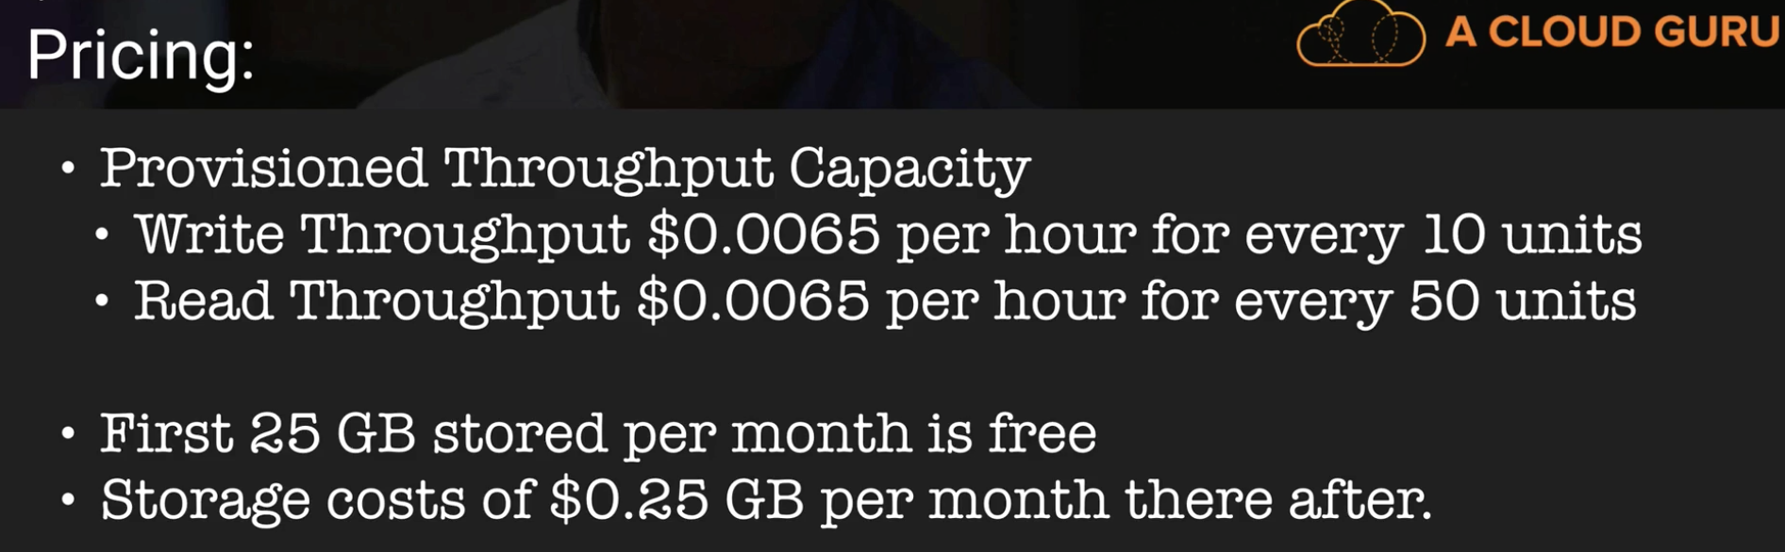

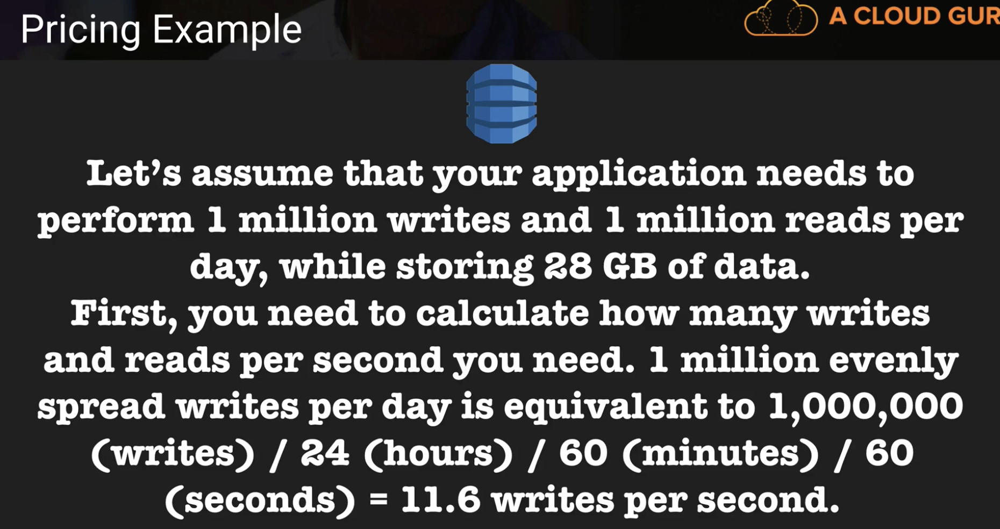

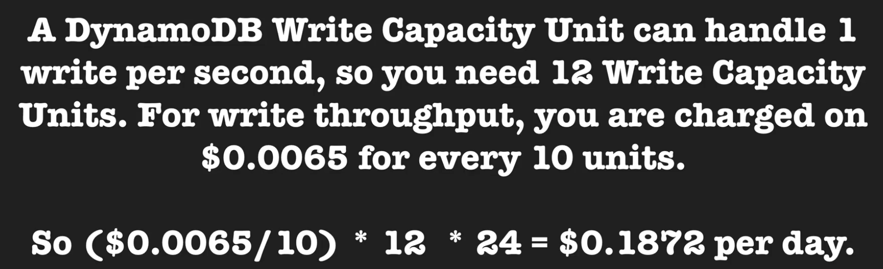

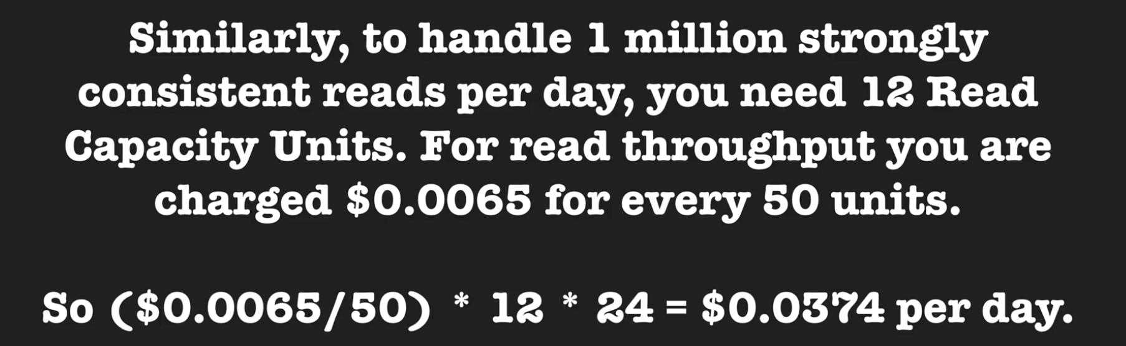

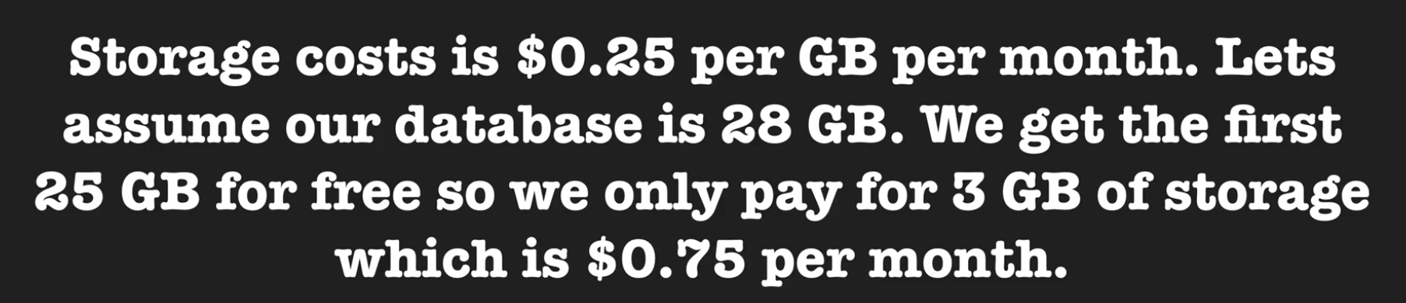

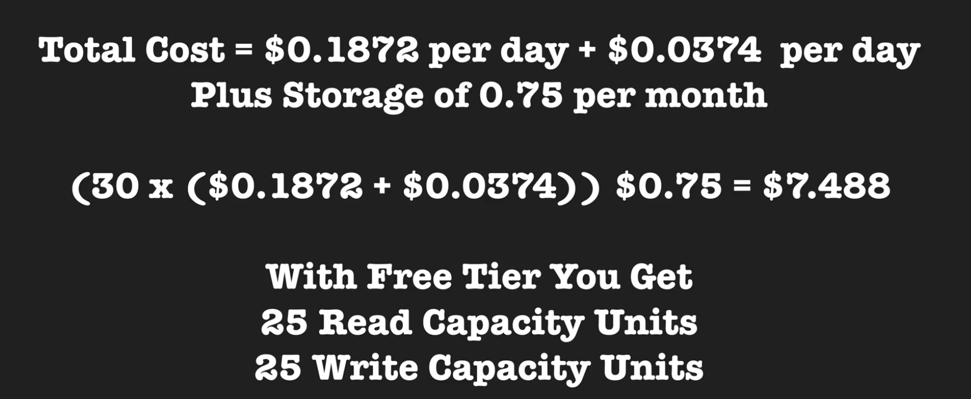

Here, 30 days multiply (read unit charge + write unit charge) plus 30 days storage cost in GB.

**Dynamo DB Indexes and Streams:**

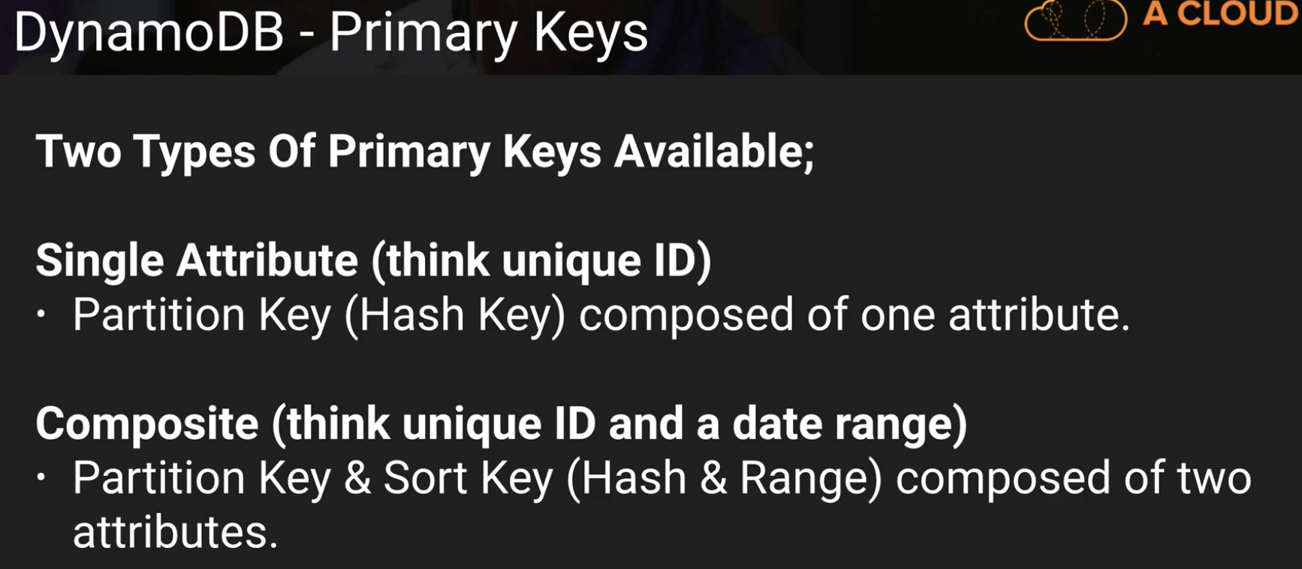

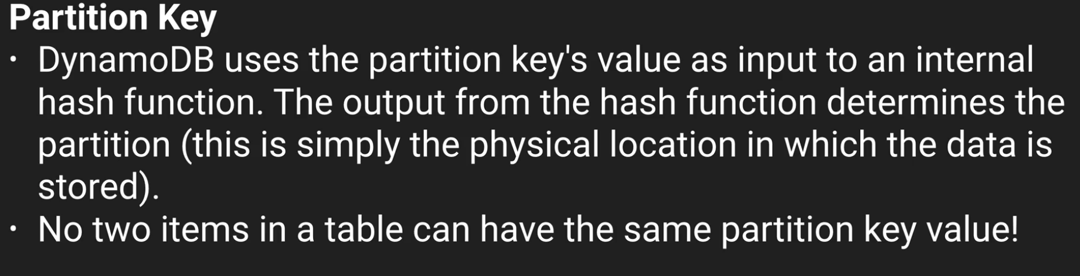

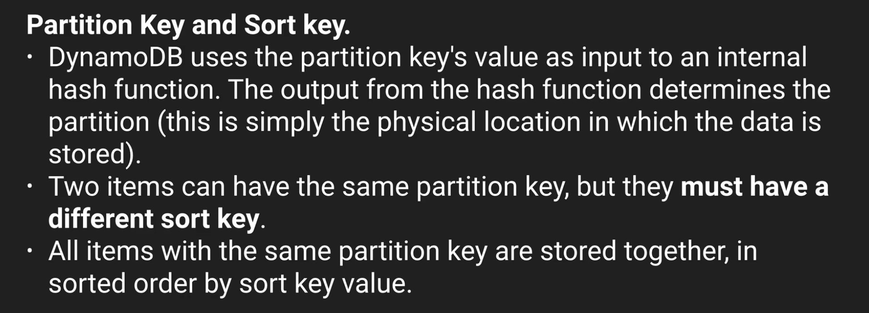

Confused with below slide ☹

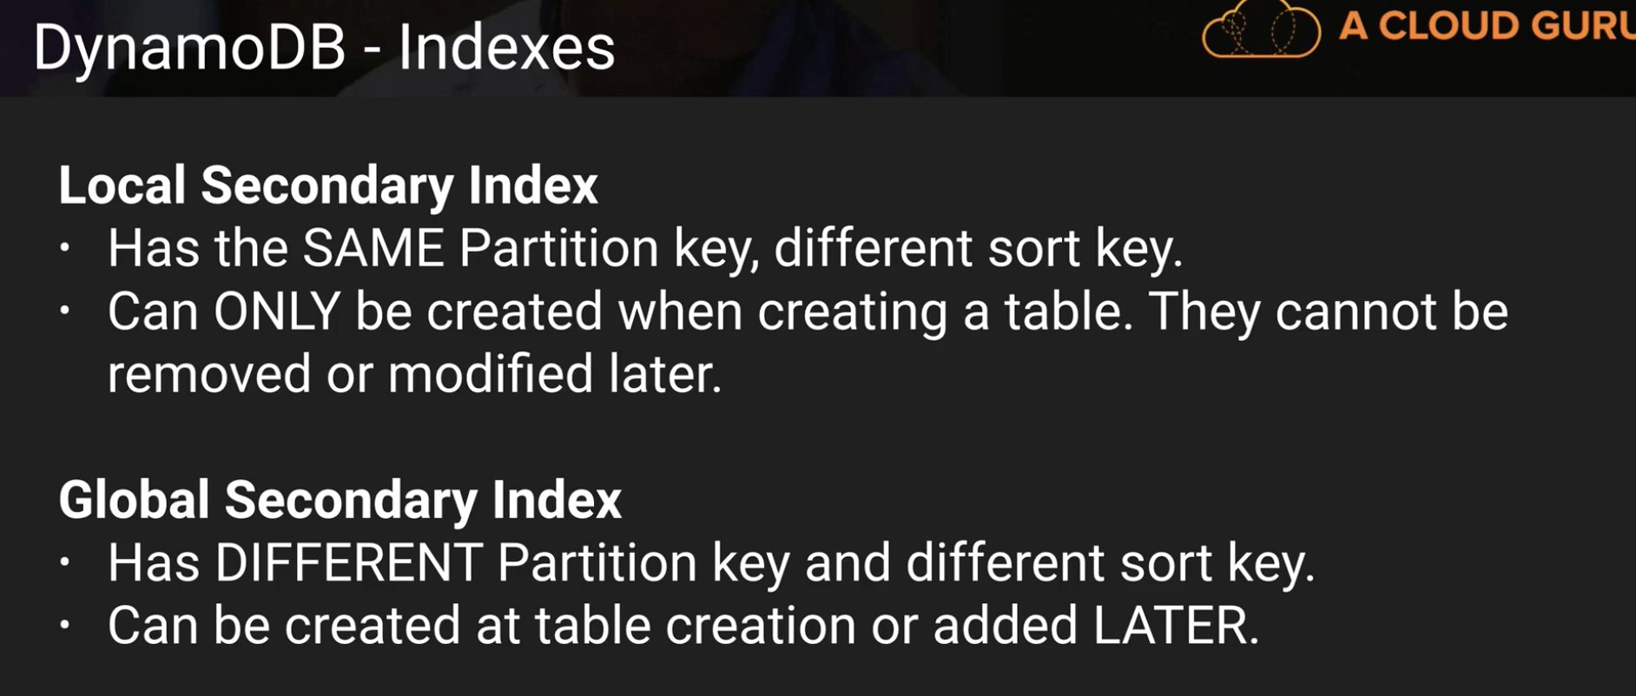

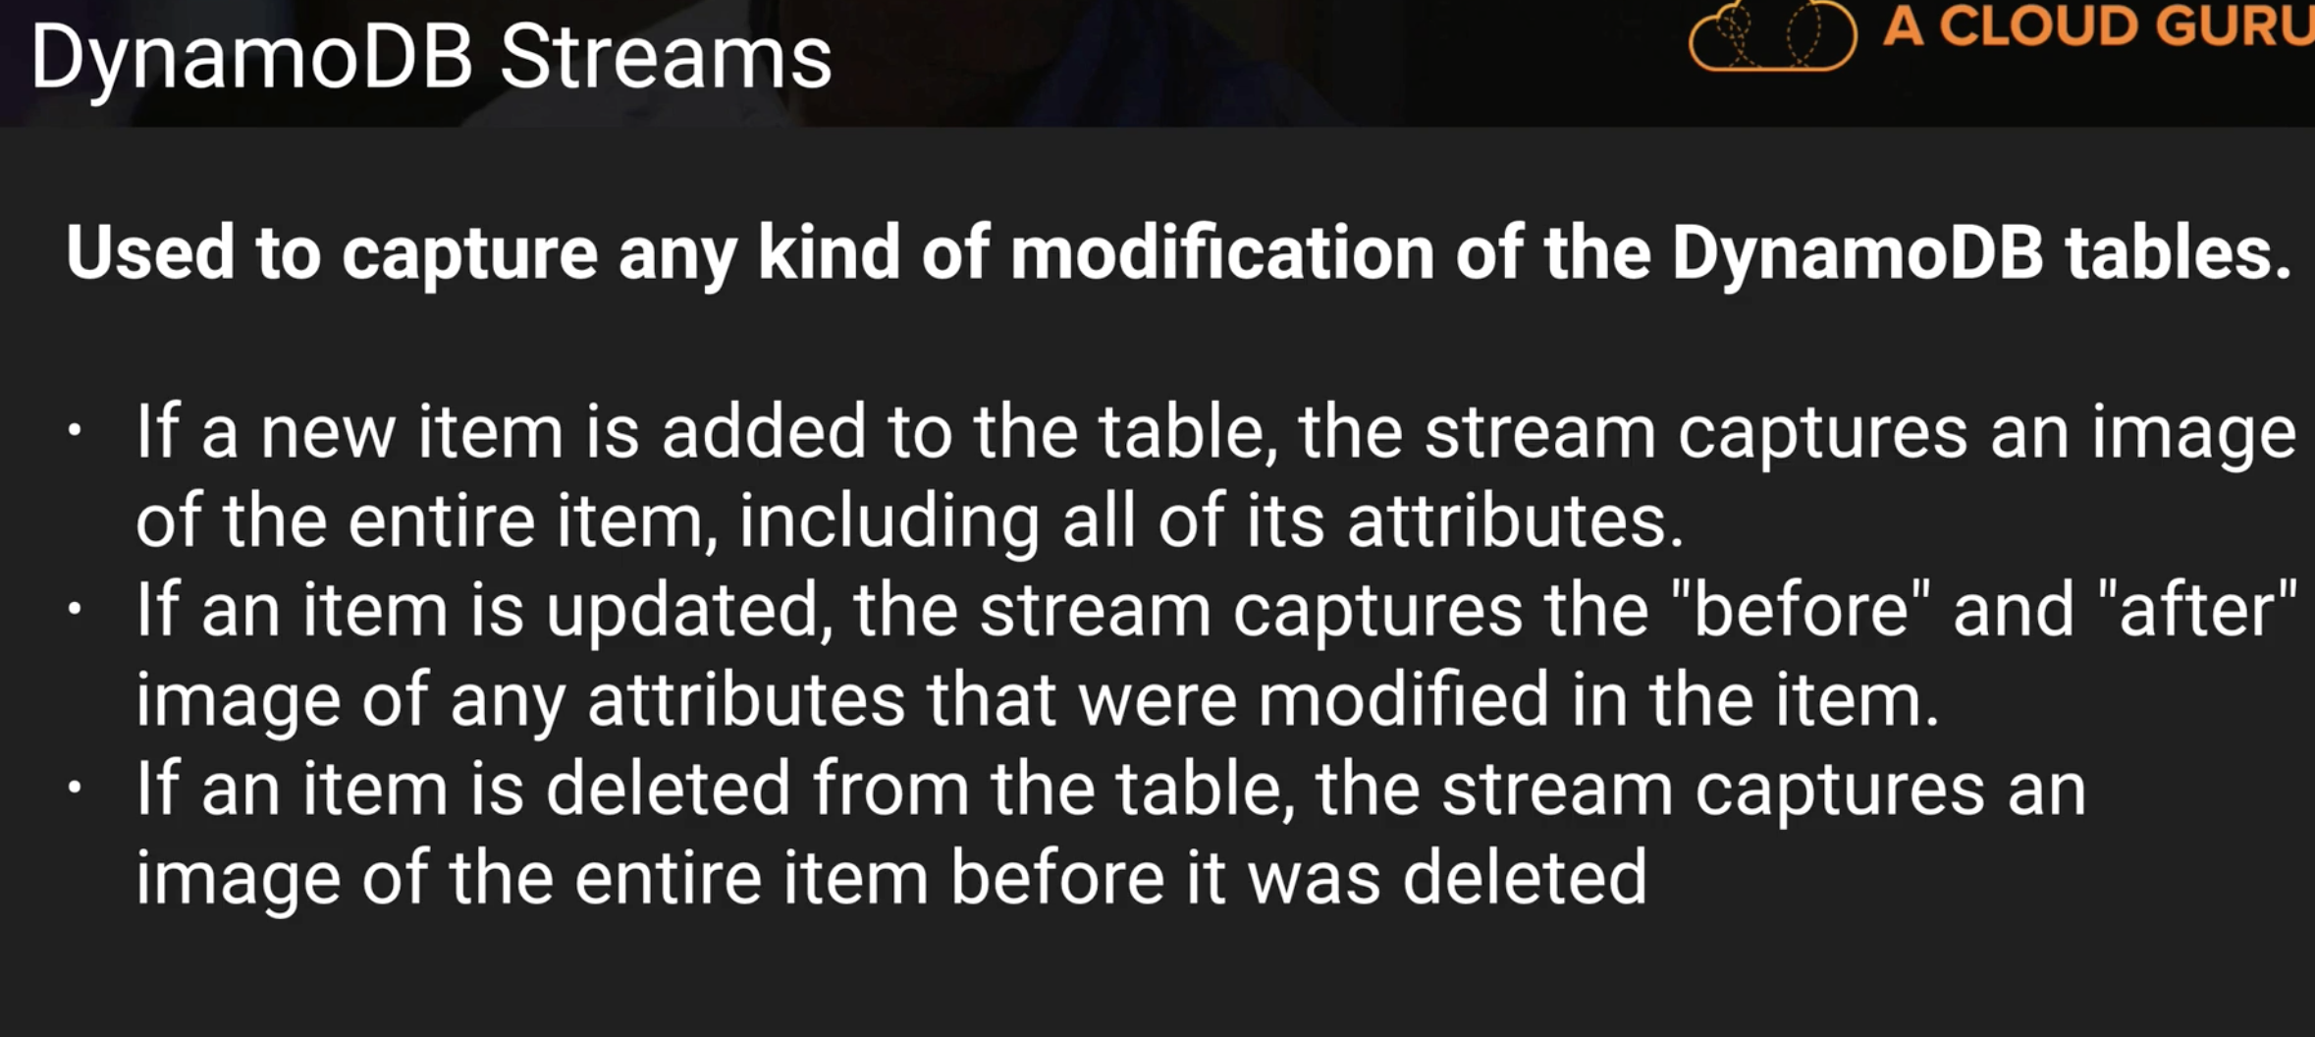

Above slide in a pictorial way:

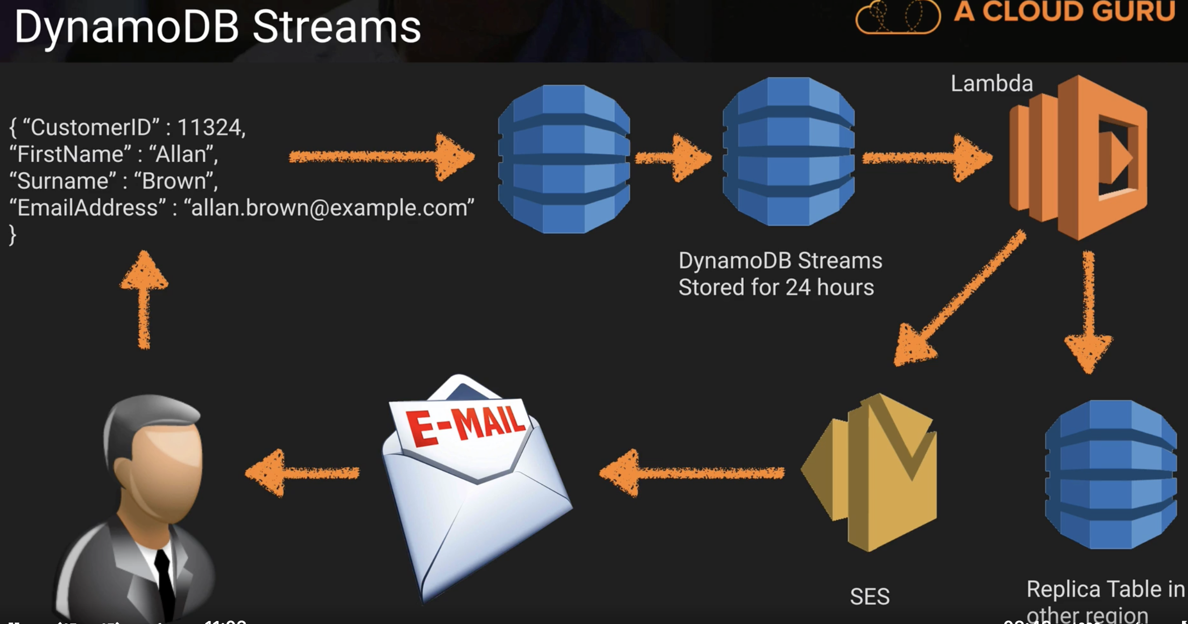

Per table you can have Local Secondary Indexes and Global indexes

Triggers -> sending welocome email to new users

Access control list in dynamo db -> you can add like facebook can only query some number of rows, etc..some rules

**Scan vs Query API Call:**

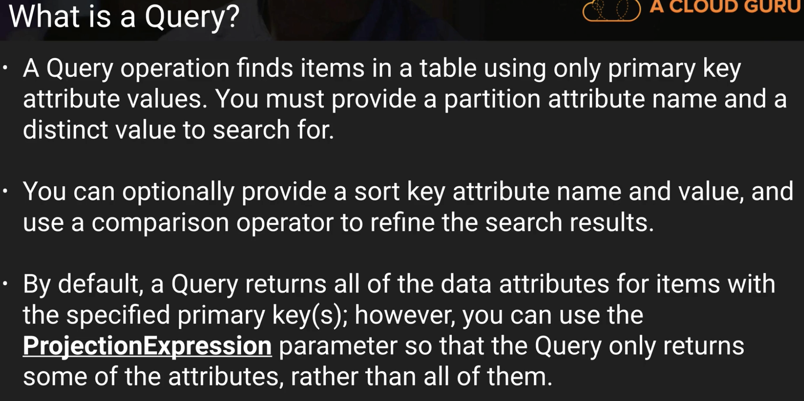

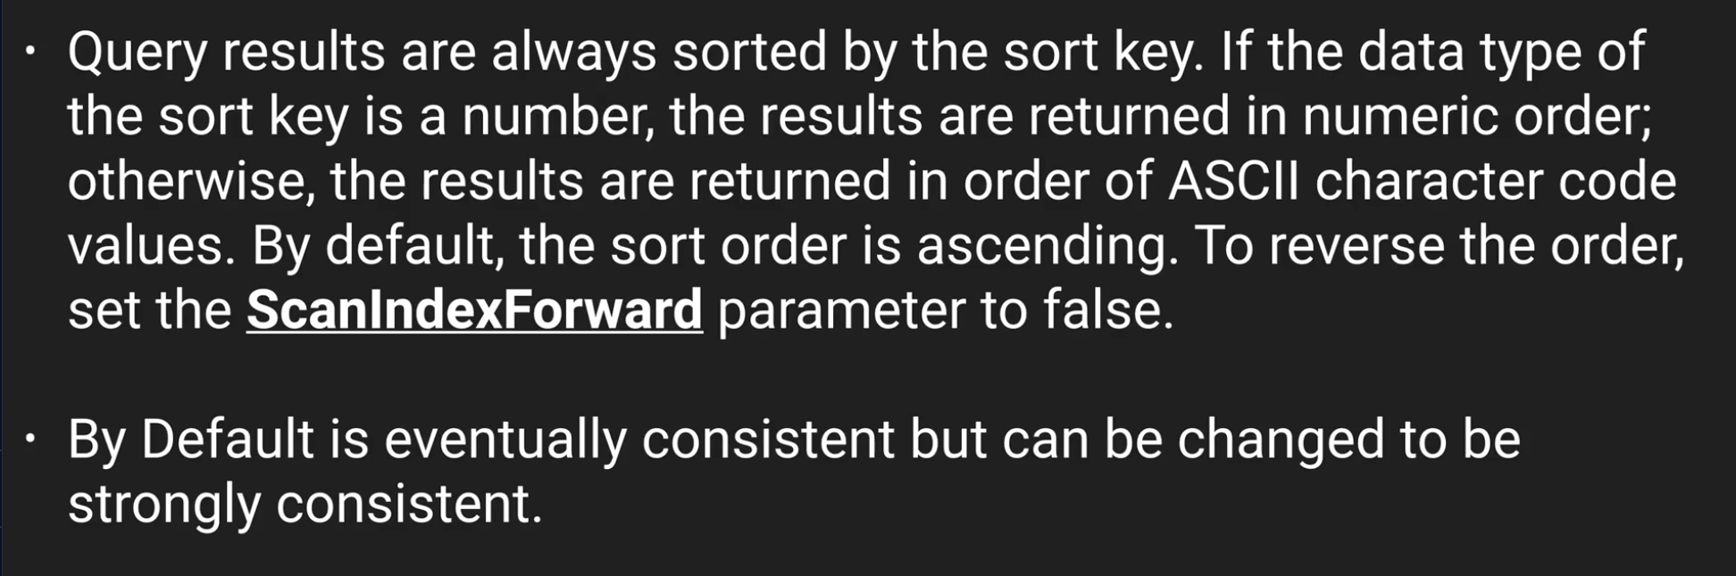

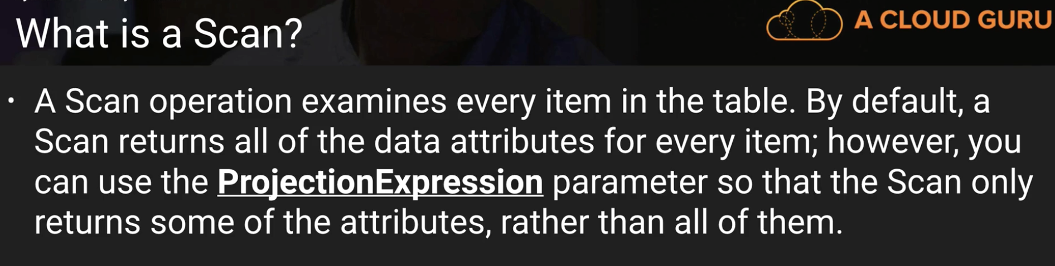

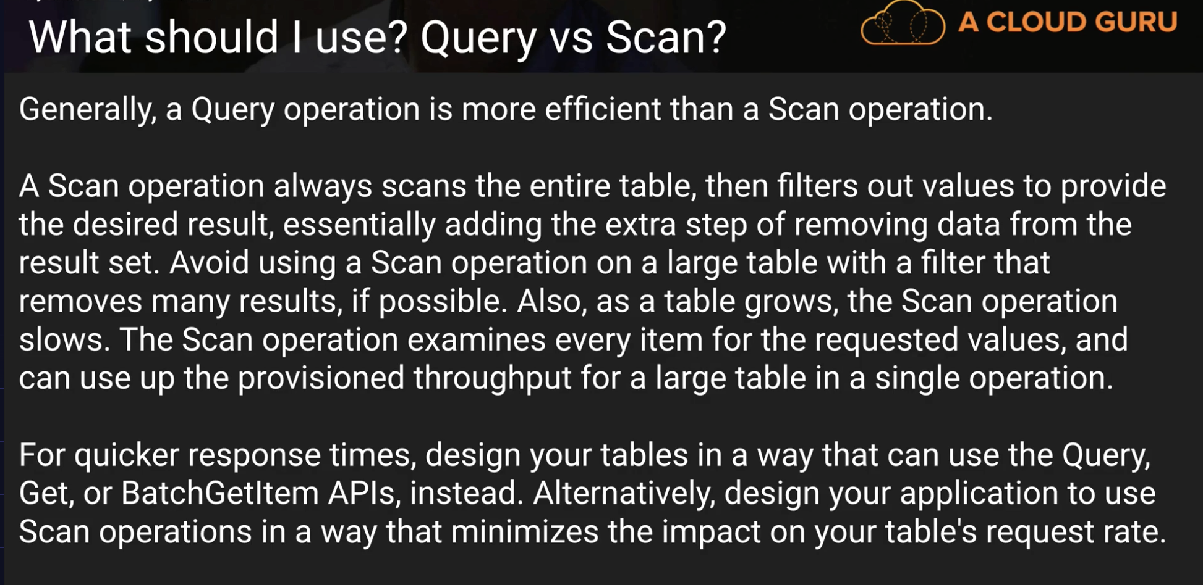

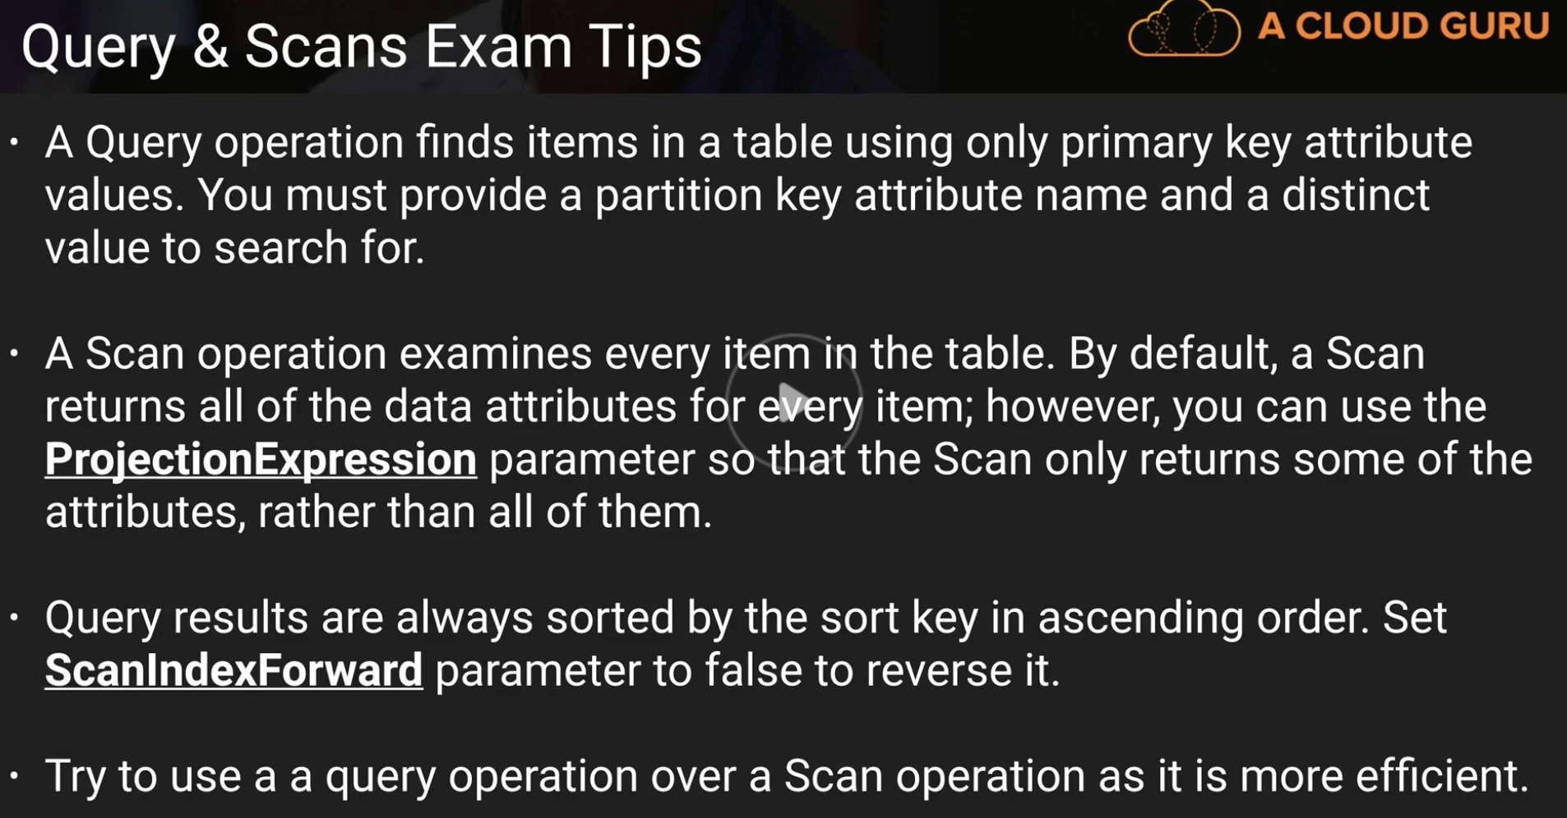

**Dynamo DB Provisioned Throughput: \*\***

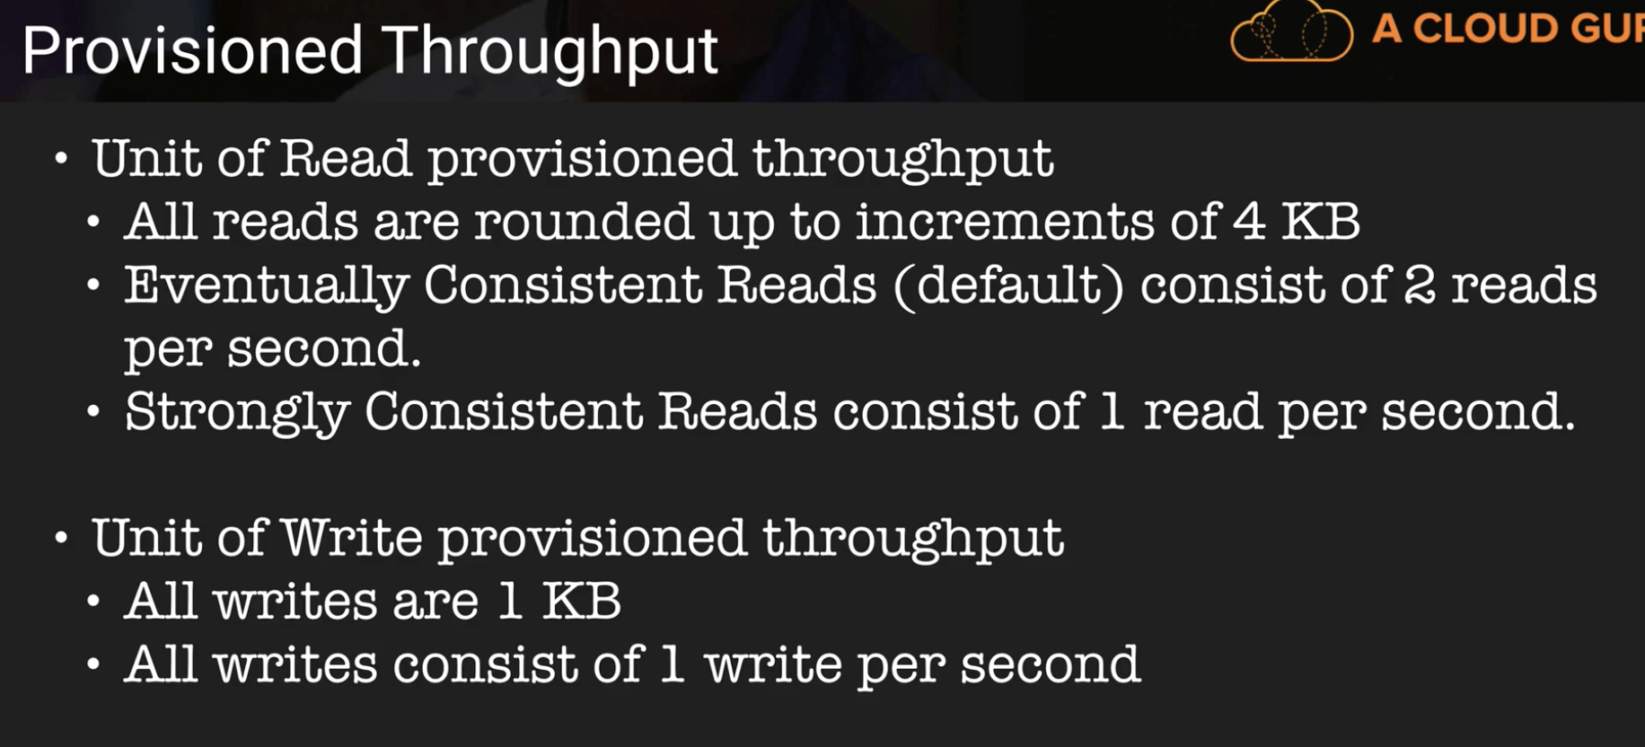

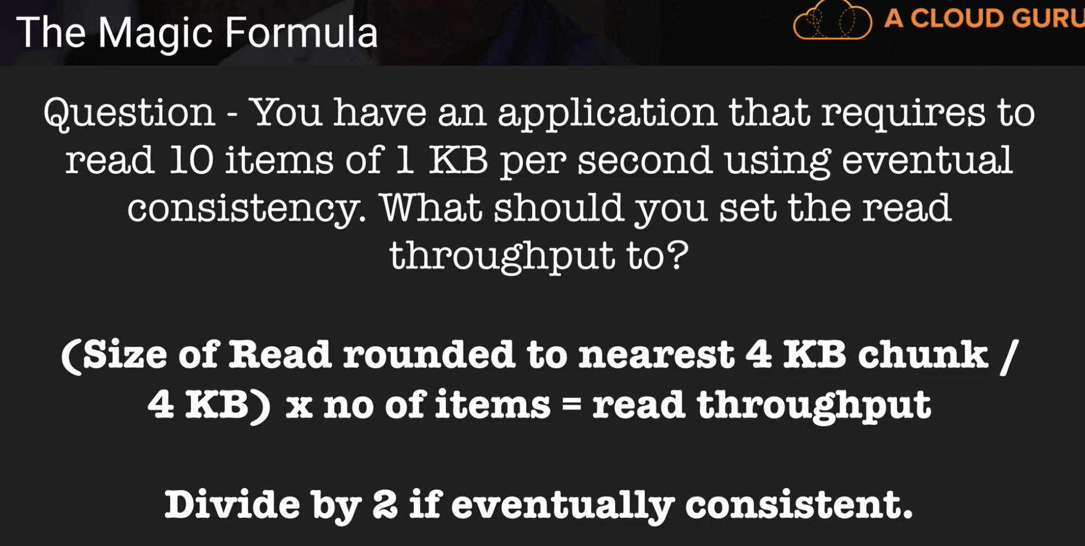

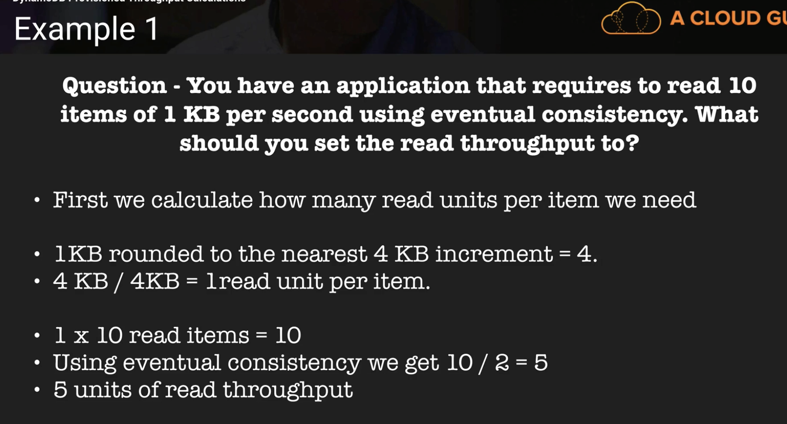

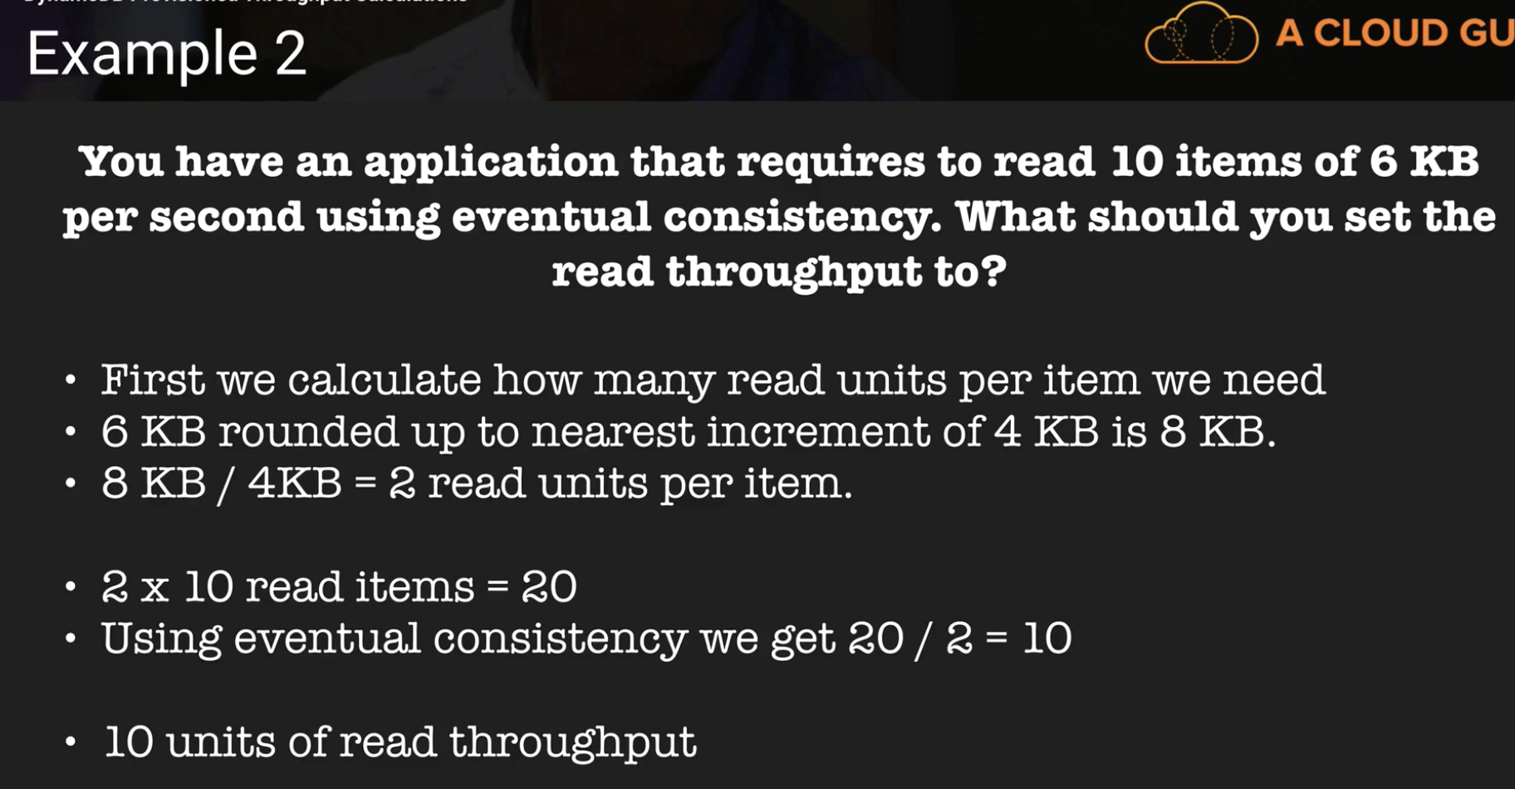

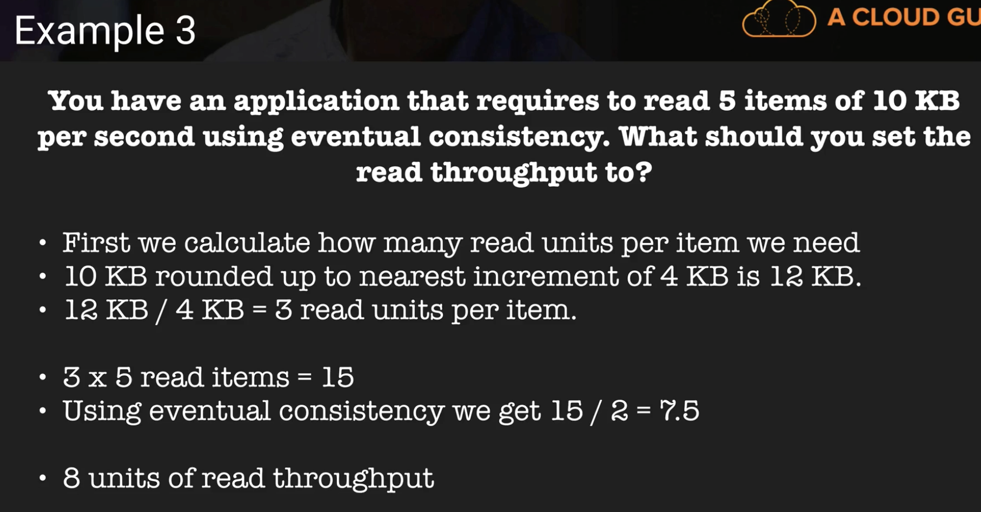

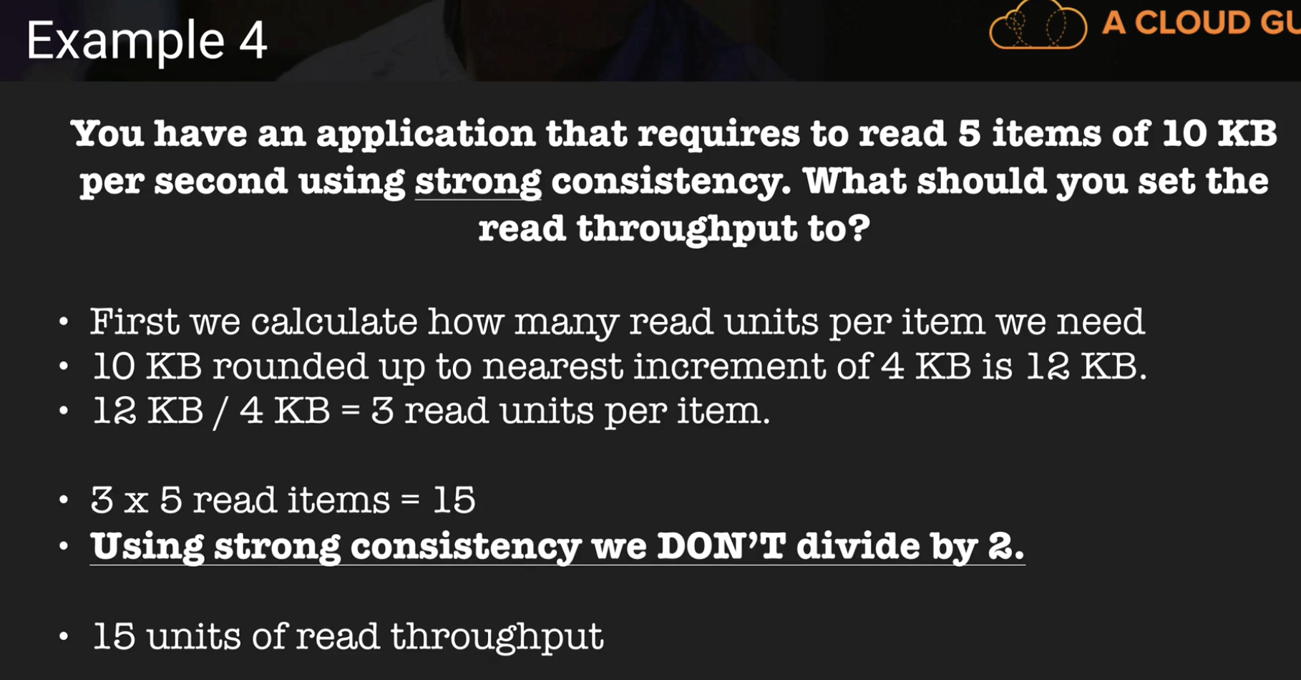

In all these questions, make sure you are given **per second, not per minute**

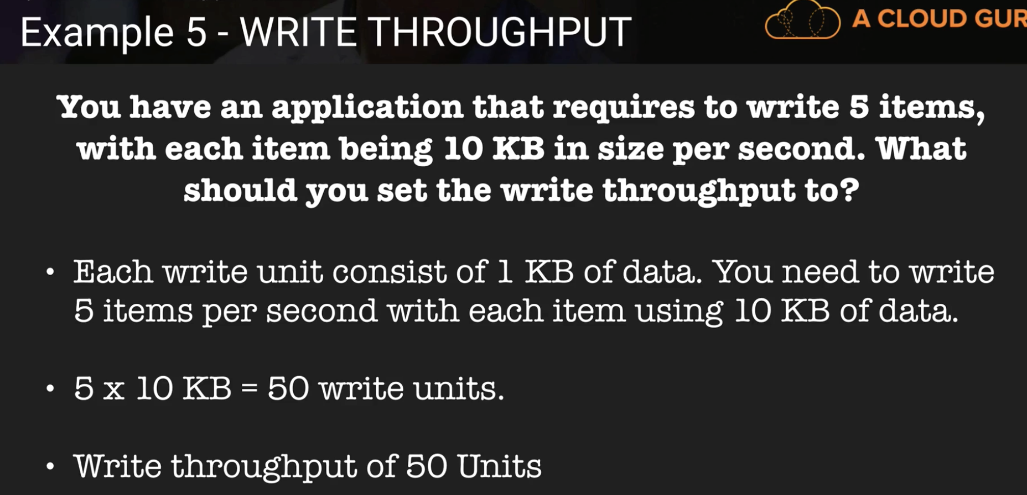

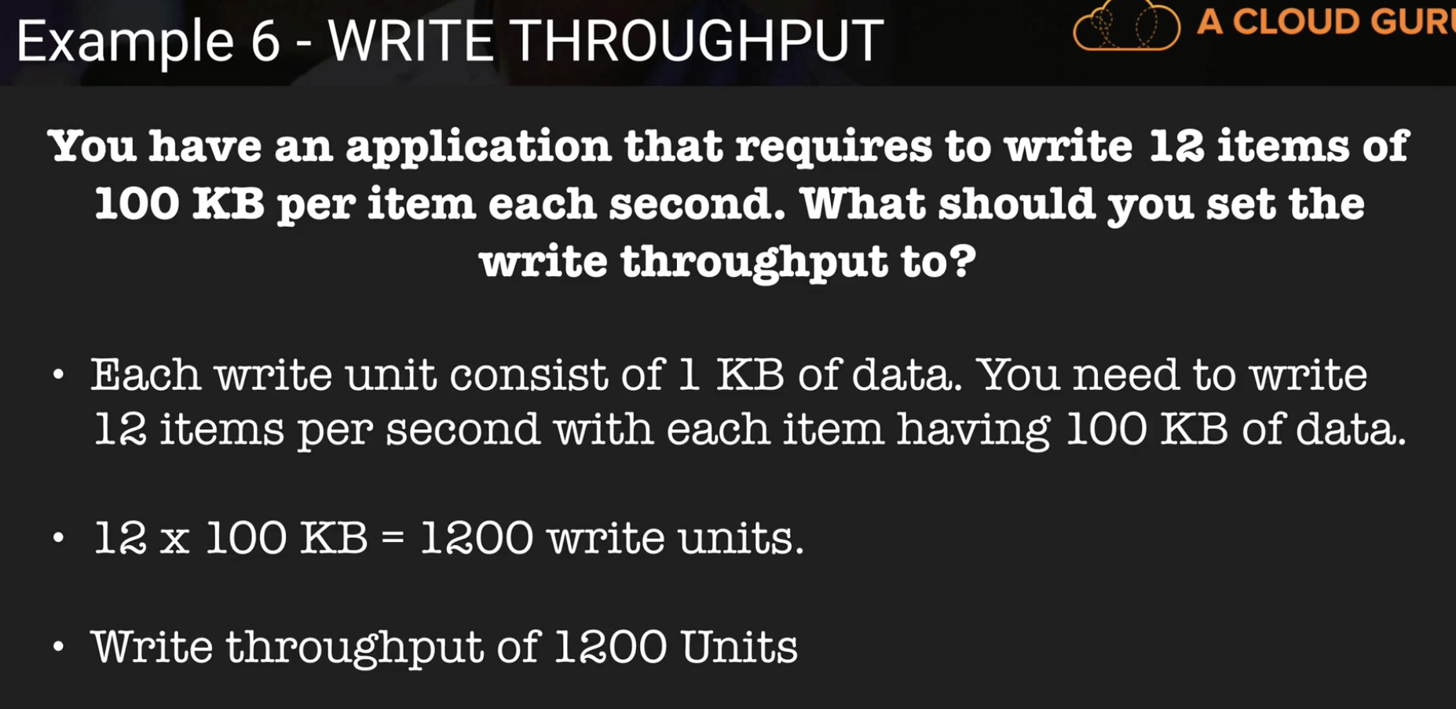

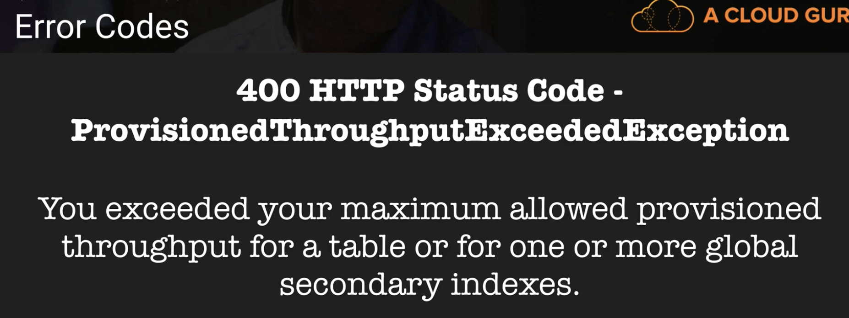

**Web Identity Providers:**

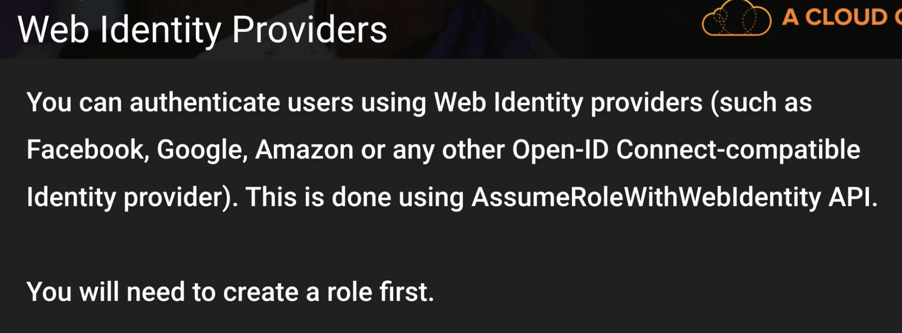

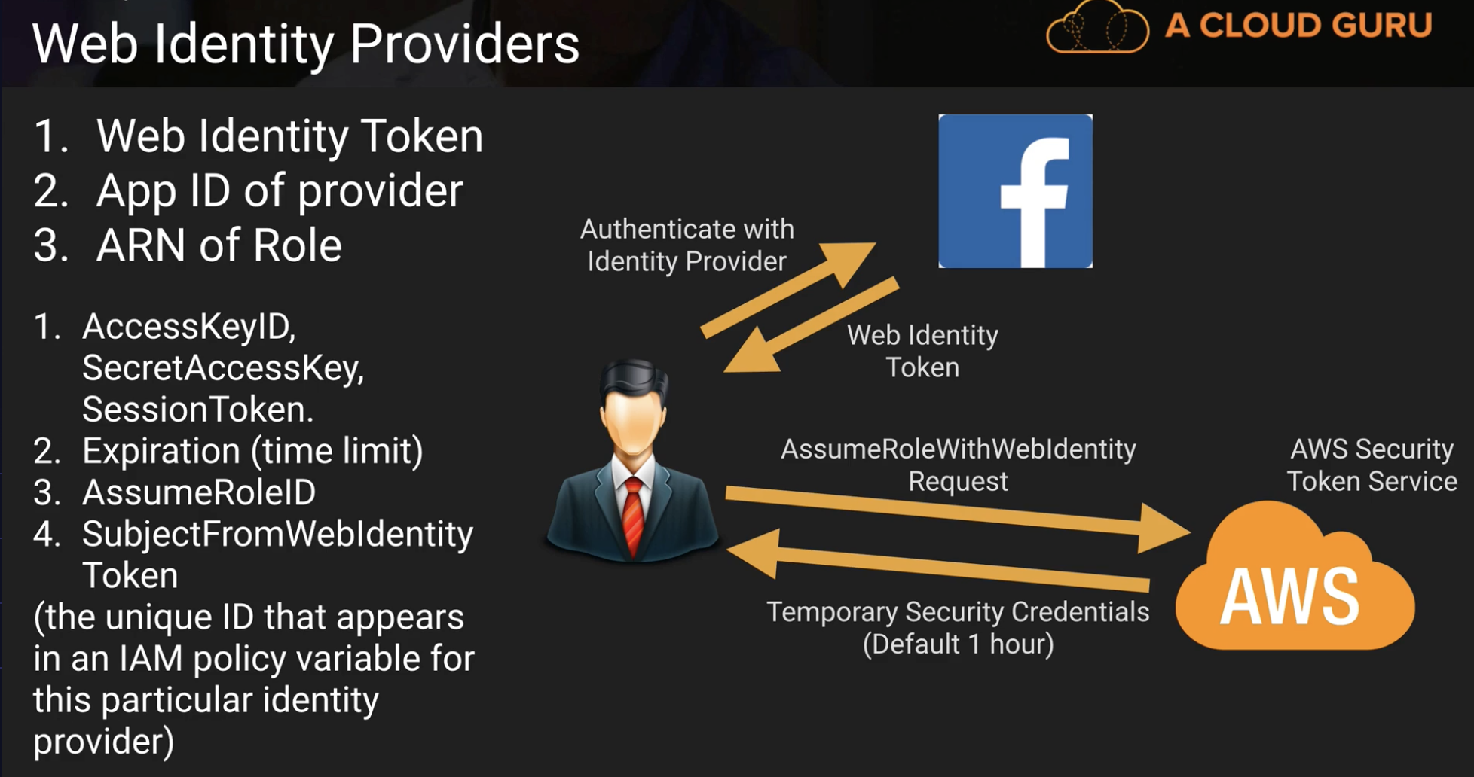

**You Just have to remember this from above slide:**

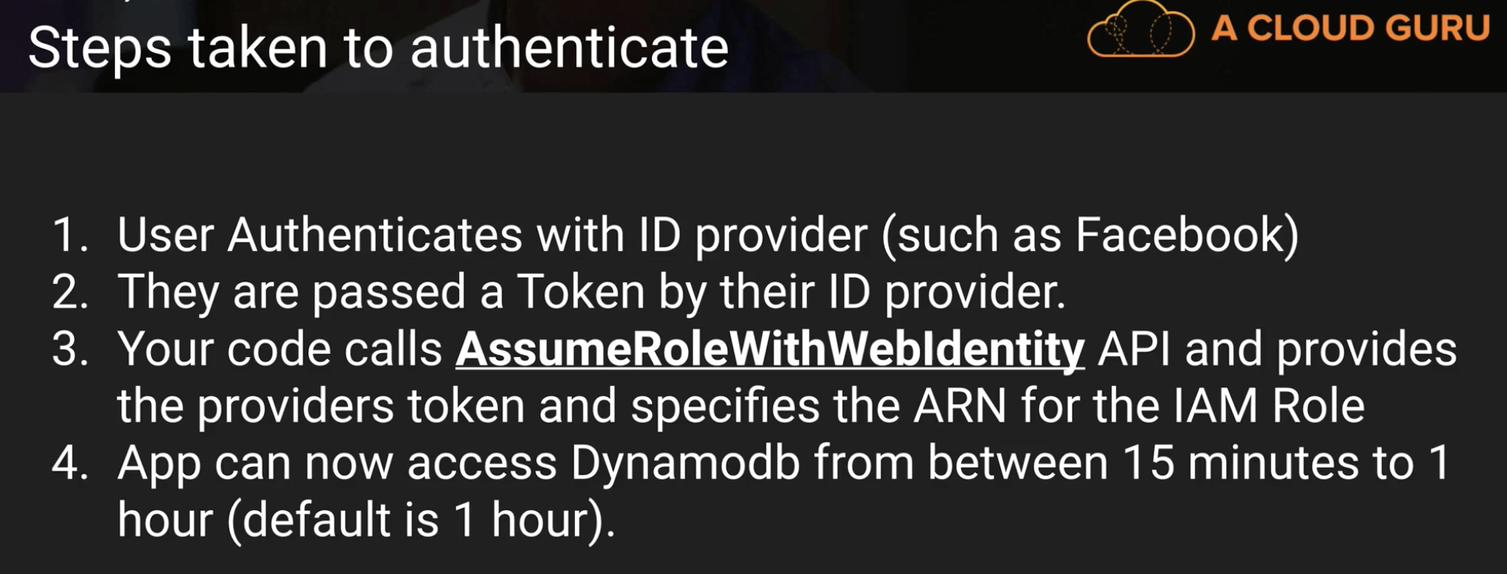

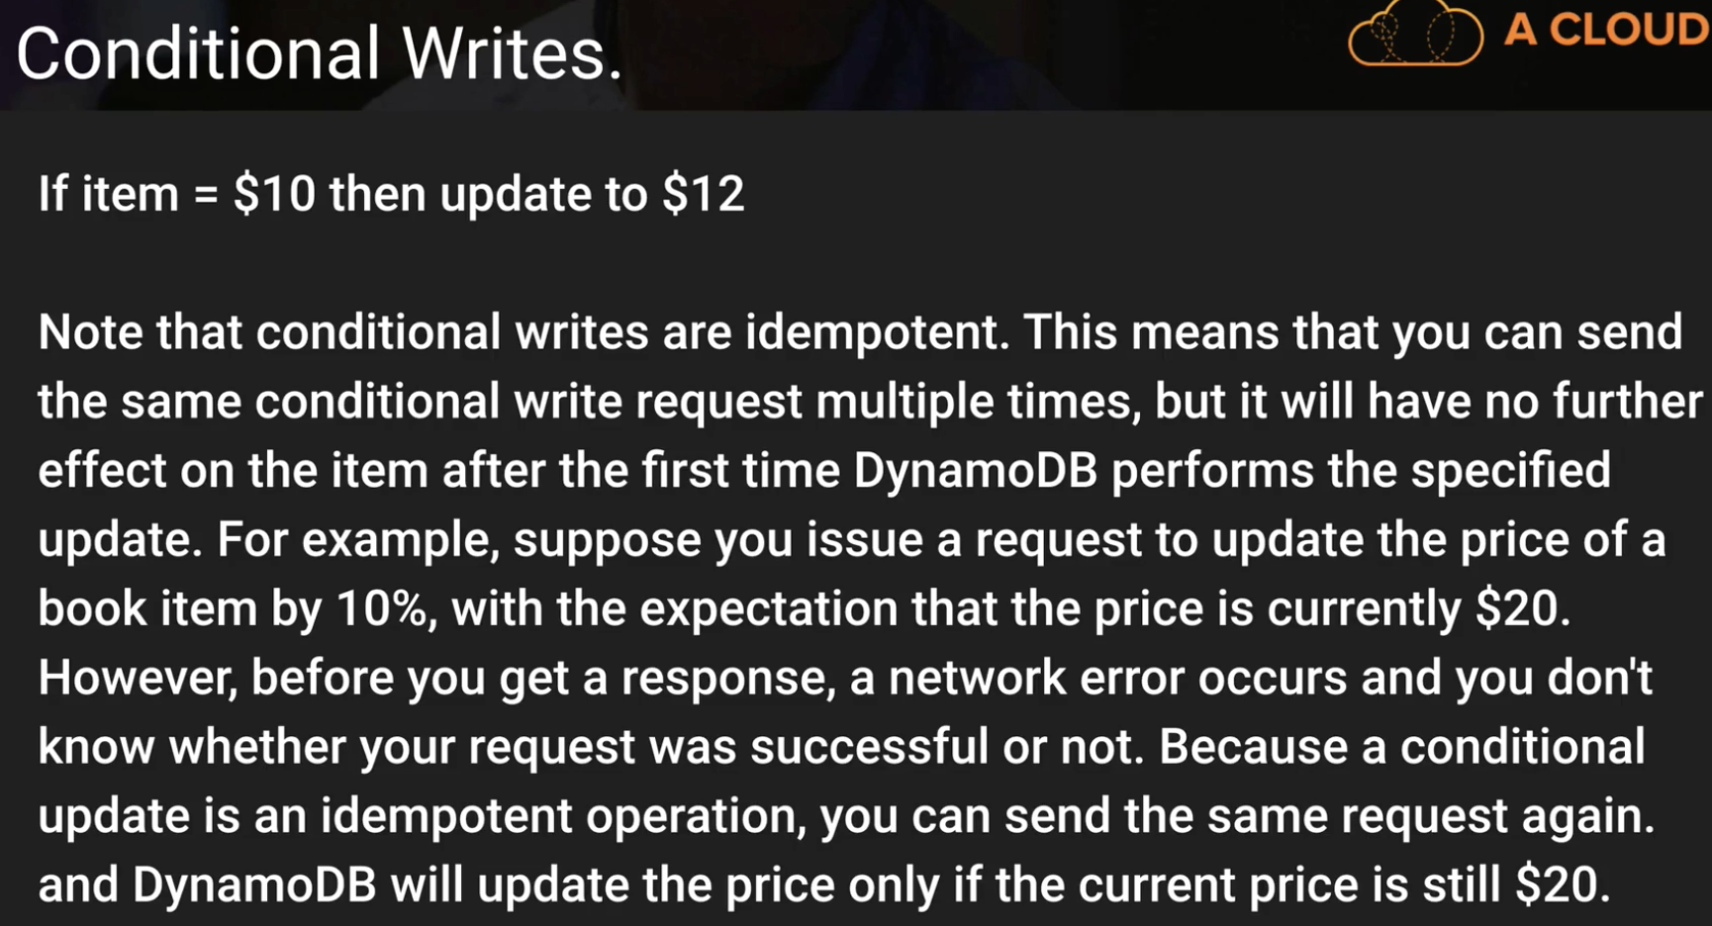

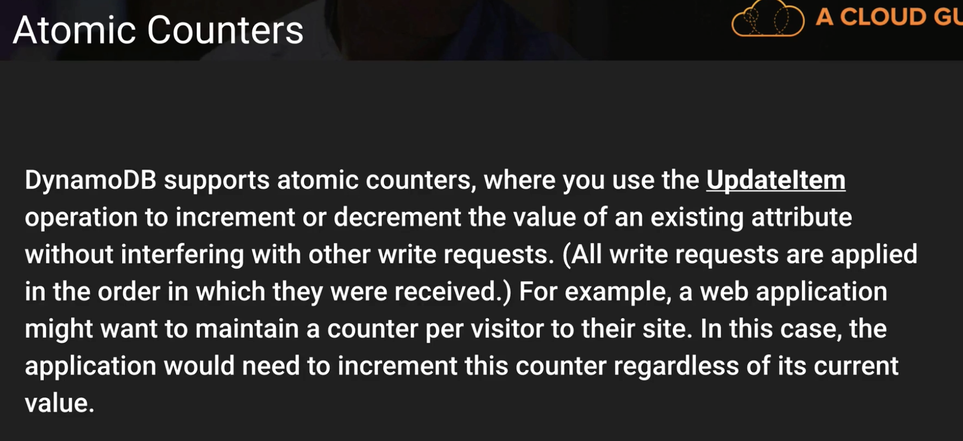

**In above slide, the example situation is important**

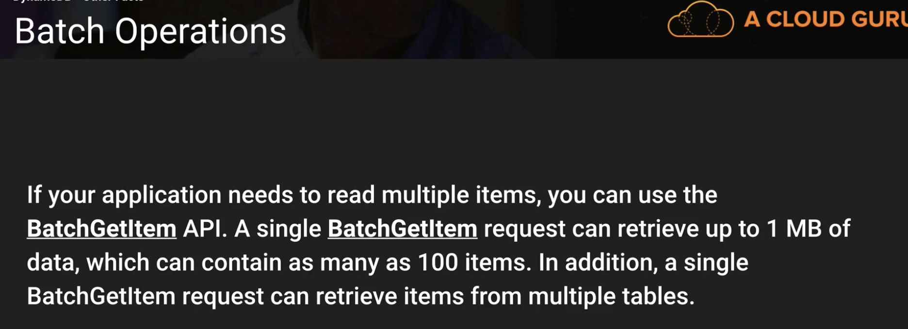

**DynamoDB Important:**

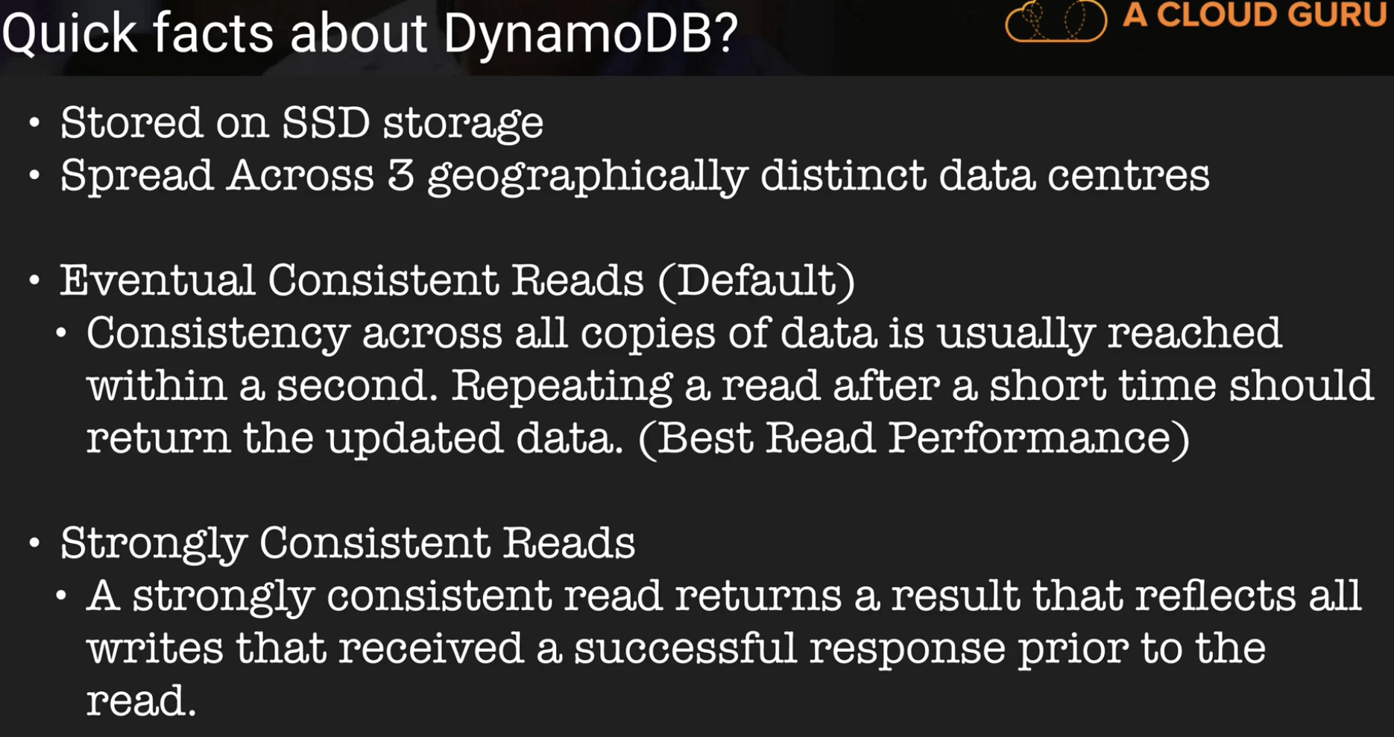

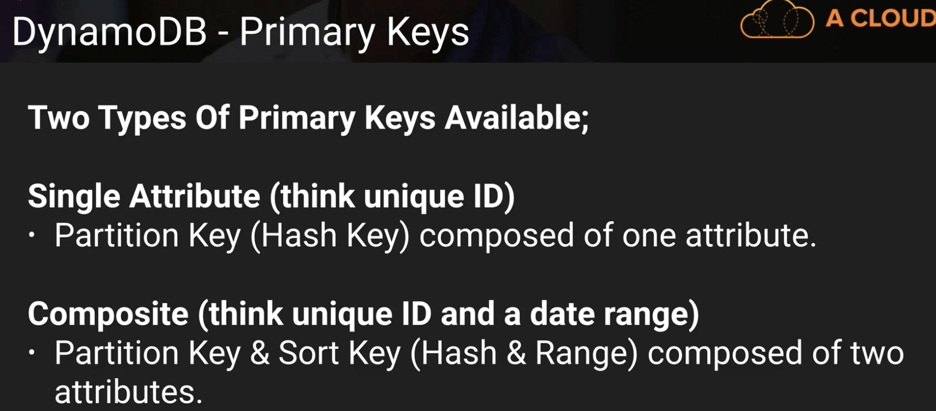

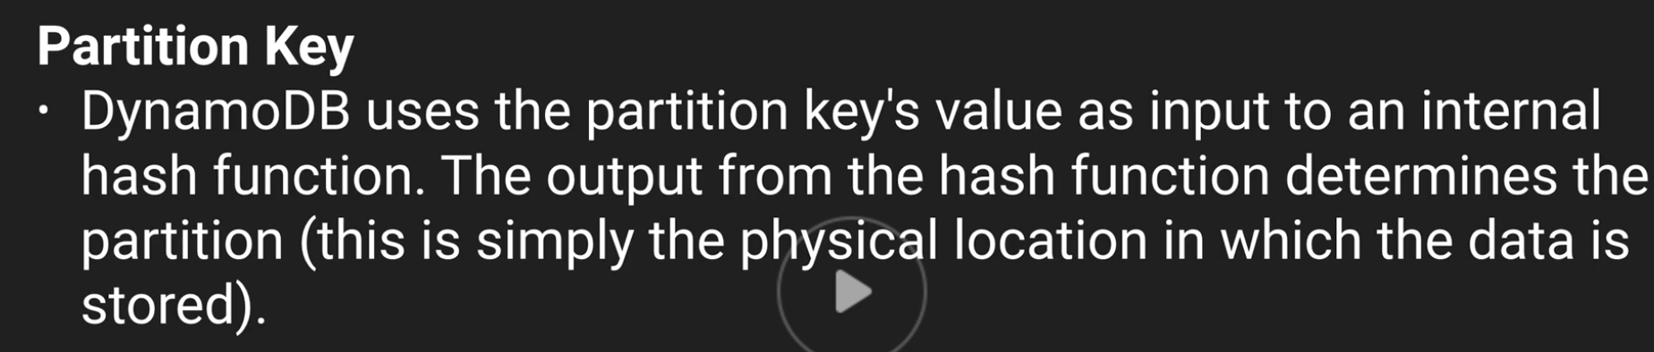

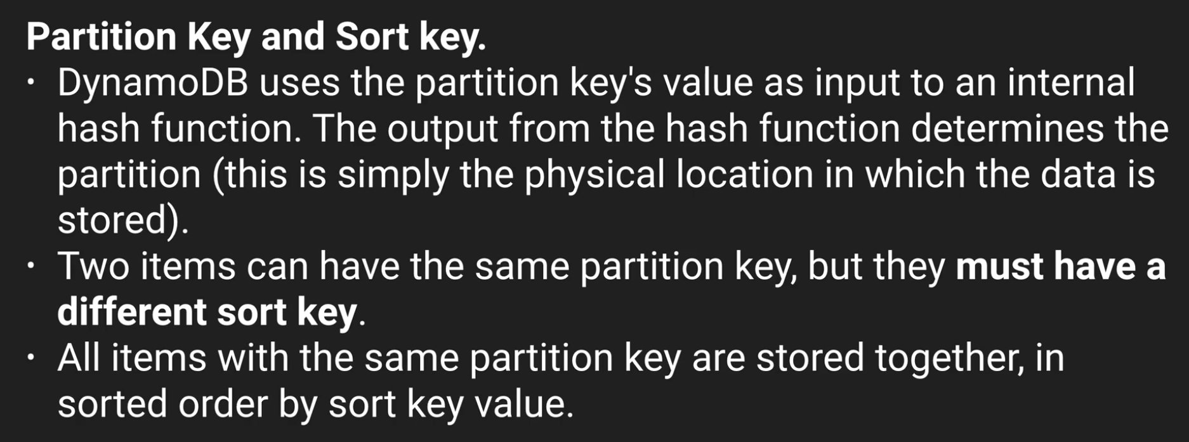

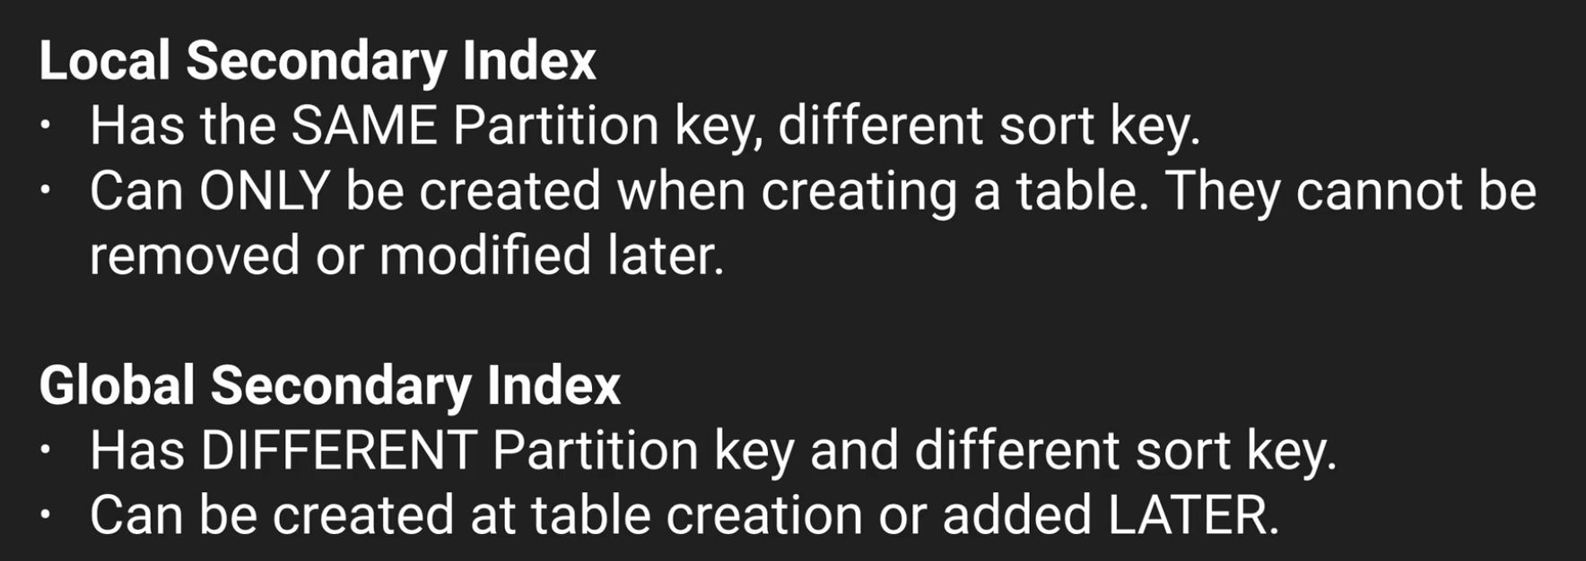

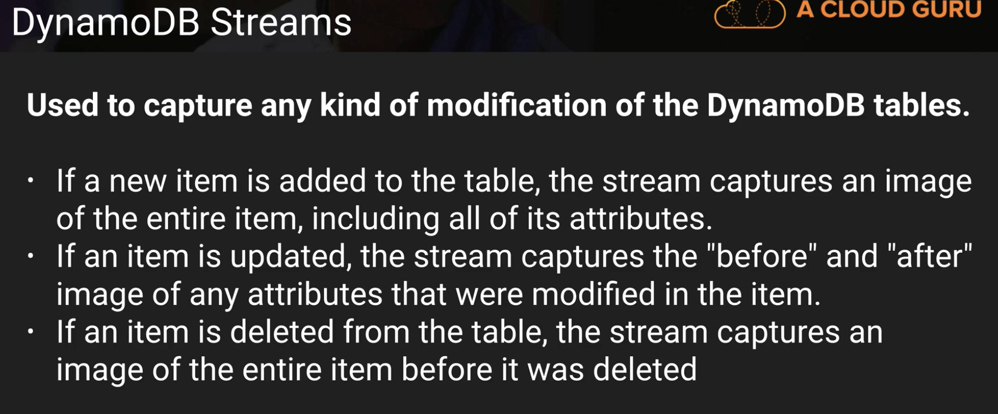

**DYNAMO DB FAQ IS VERY VERY IMP than other FAQs**

**IS DYANAMO DB FAQ Worth it?**

(answering my own question, sorry but I thought this was worth sharing):

I just read through the whole DynamoDB faq after going through the lectures here. It cost me about 2h in total but I must say it was very well worth it, especially since there are a lot of things that changed since this lecture was recorded, there's..

* **auto scaling** which was introduced June 2017
* **backup/restore** which was introduced November 2017
* **time to live** management, introduced February 2017
* **DynamoDB Acceleration (DAX)** which is a caching layer which became generally available June 2017
* **global tables** introduced November 2017
* **encryption at rest** introduced just 6 days ago in February 2018

So it seems the feature set has almost doubled in 2017 so even if those things are not asked in the exams it's certainly interesting to know that they exist.

Personally I found the sections about secondary local indexes a bit lengthy and if you skip something then skip those, as they are covered in the video lectures well enough.

Batchgetitem()

<https://docs.aws.amazon.com/amazondynamodb/latest/APIReference/API_BatchGetItem.html>

**Provisioned throughput limits can be changed by sending a ticket to AWS support**

**SQS Simple Queue Service: (3 to 4 Questions)**

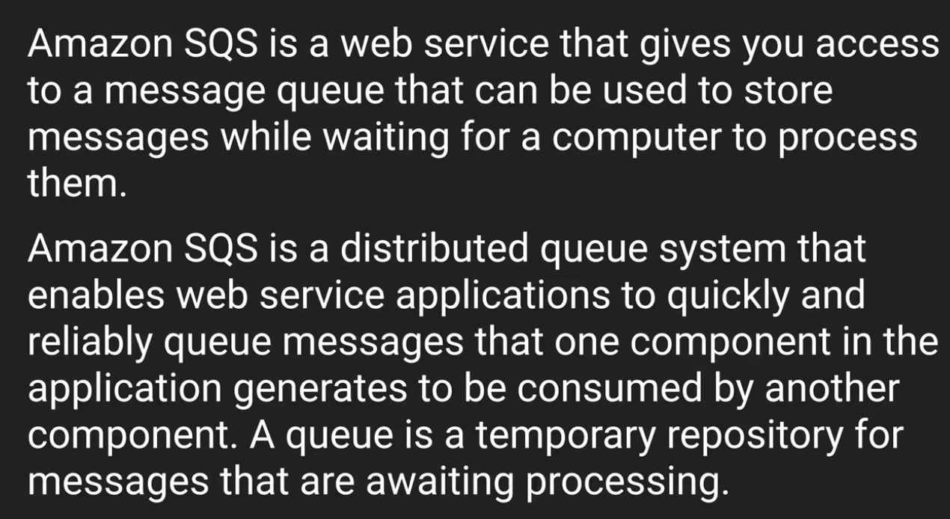

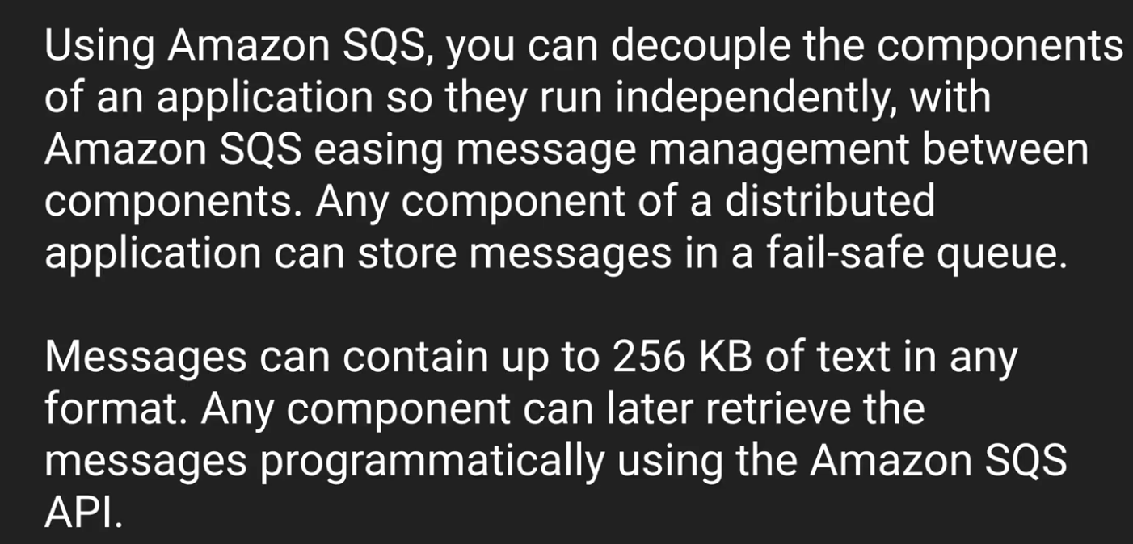 **Here 256KB is \***

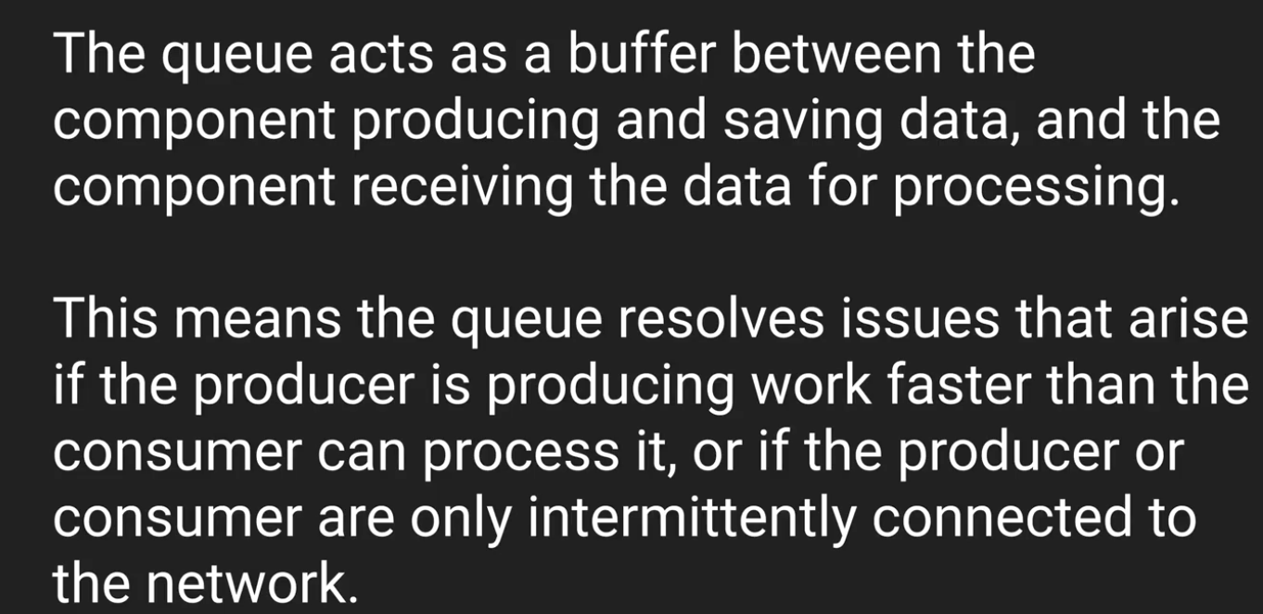

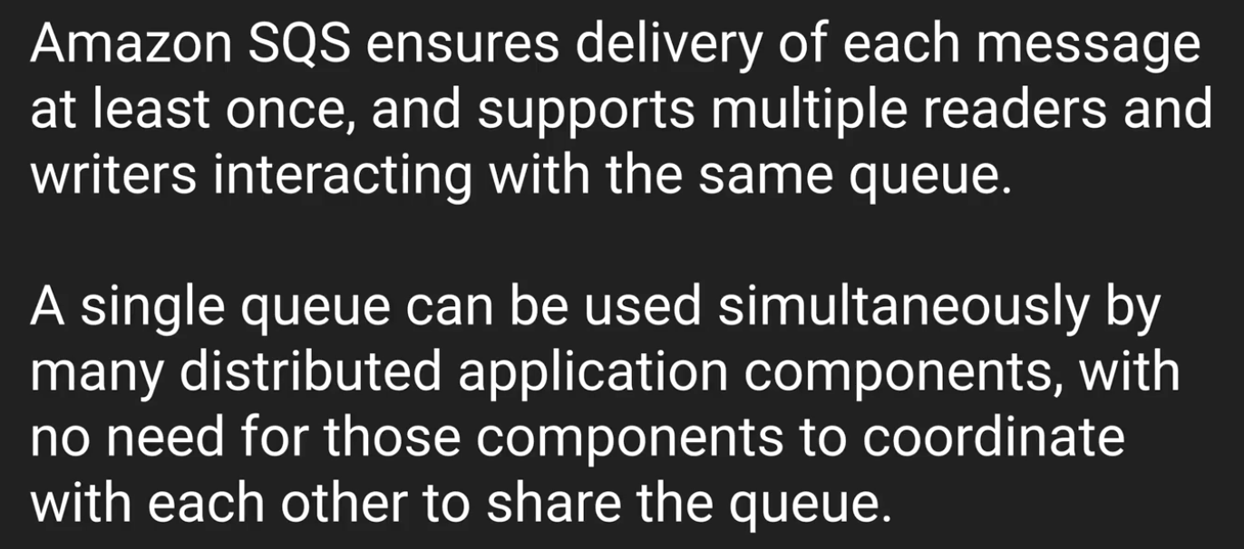

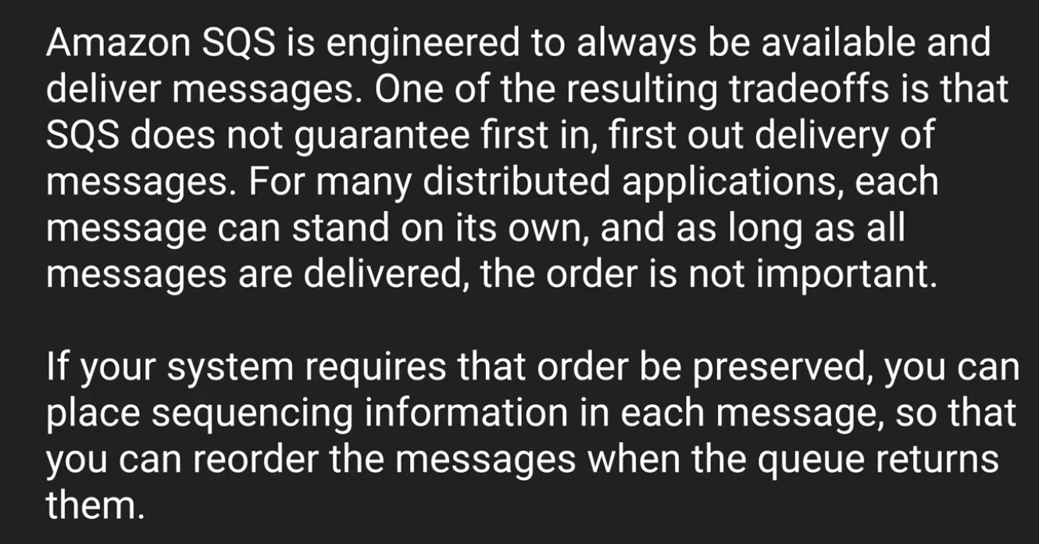

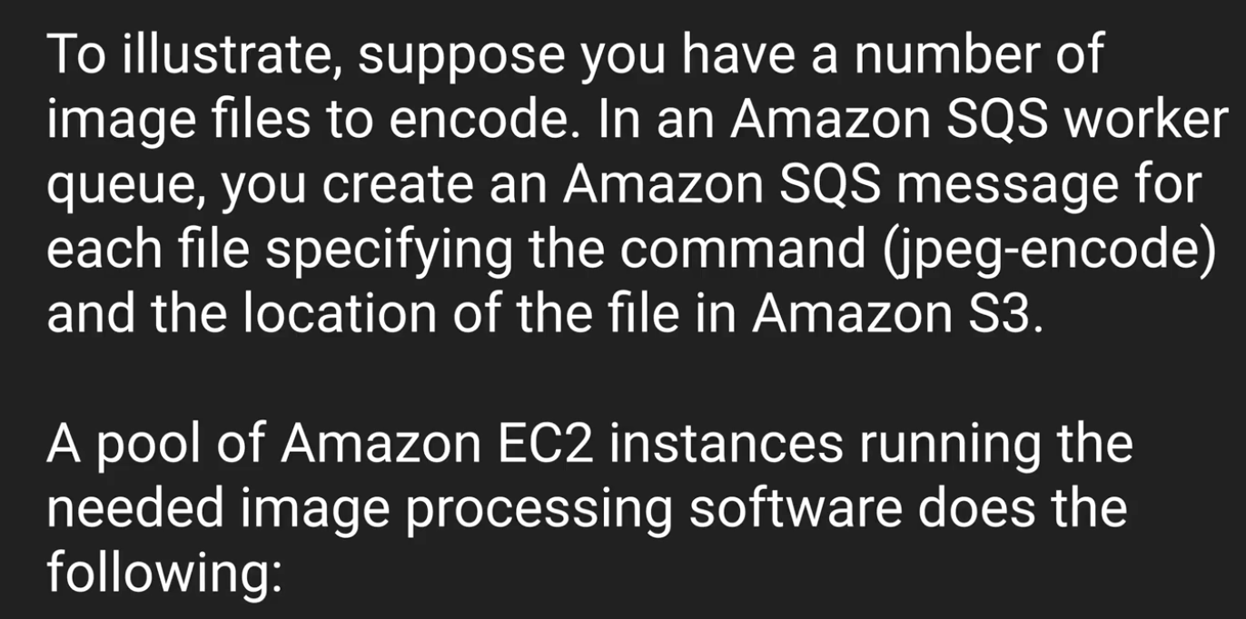

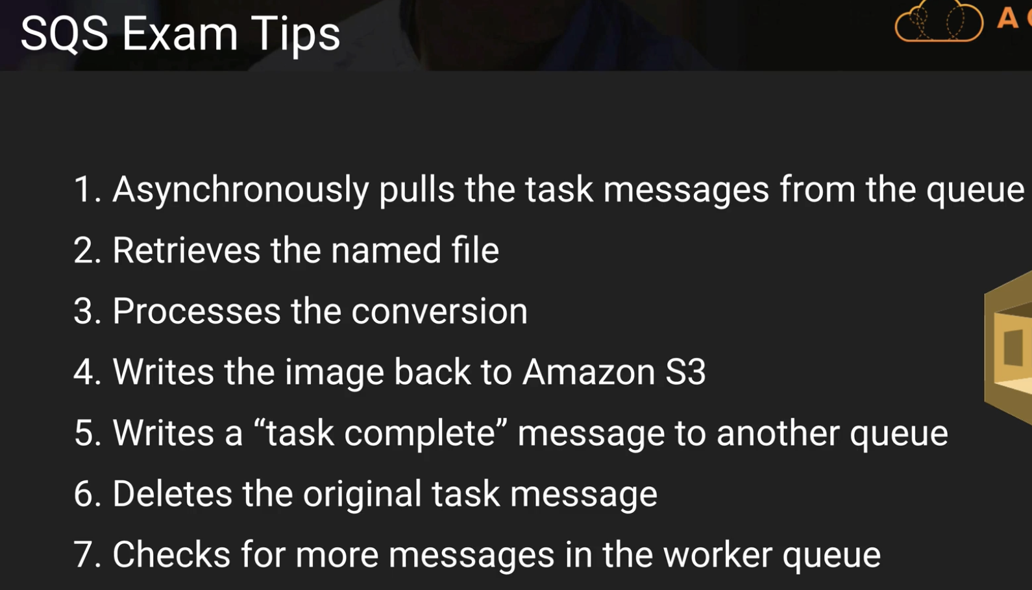

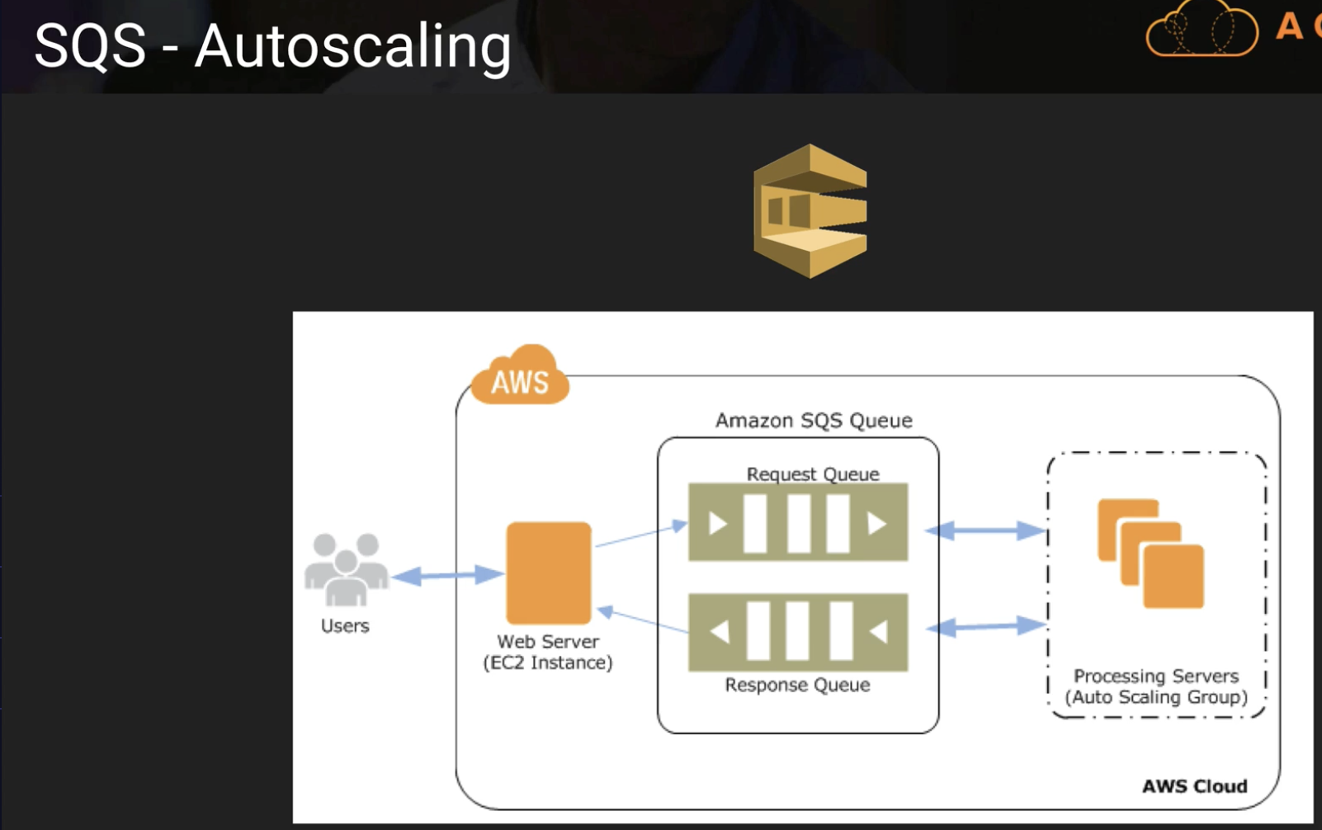

**In the below slide, SQS does offer FIFO – Mistake in Slide**

**Default Visibility time out – 30 sec**

**Maximum visibility time out – 12 hours**

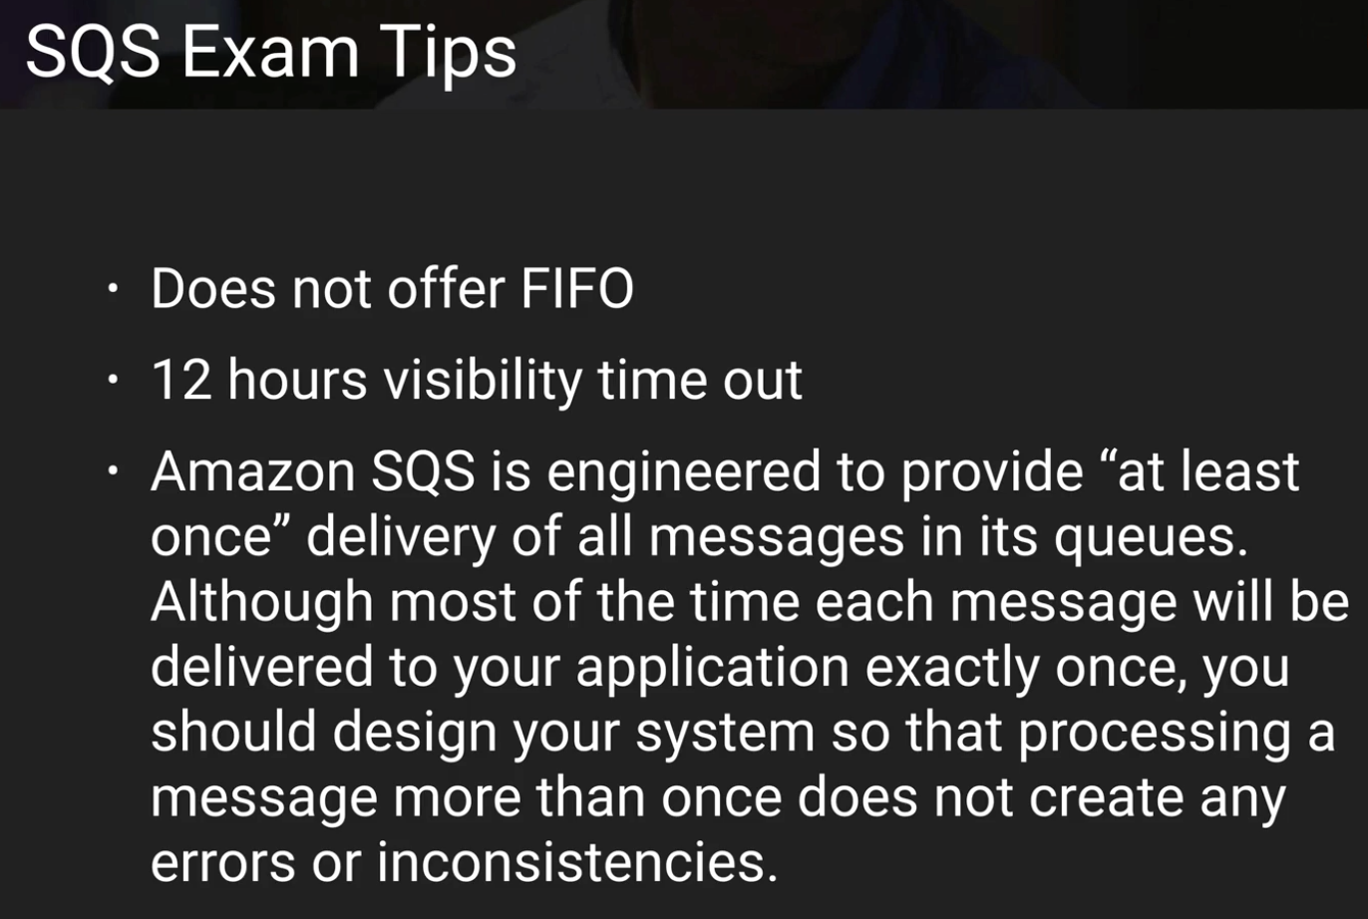

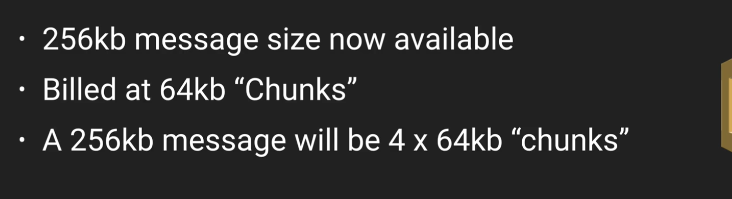

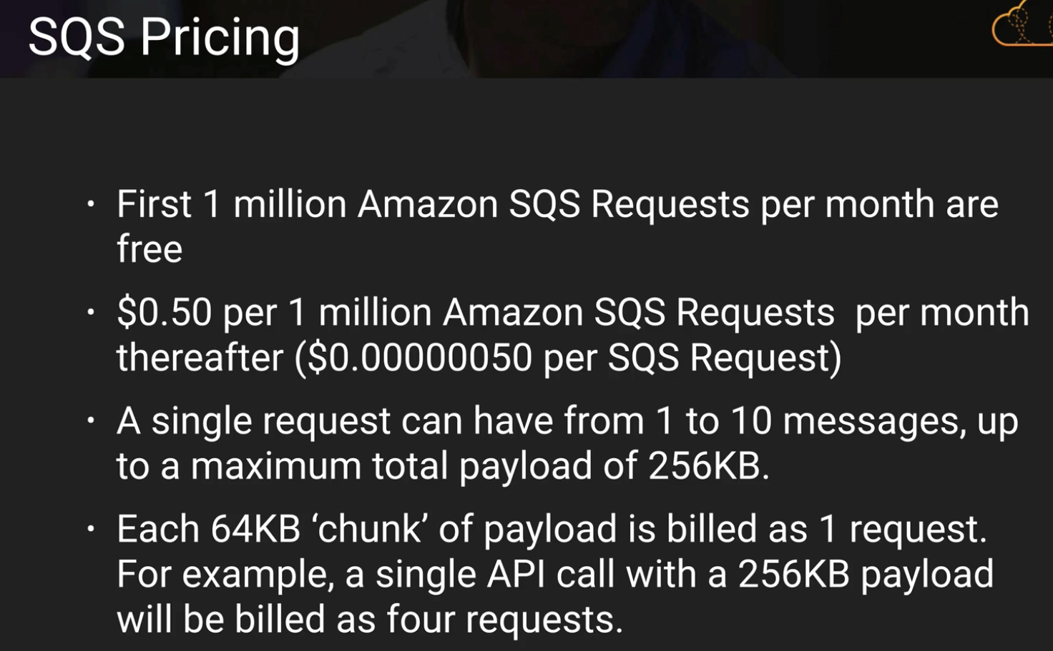

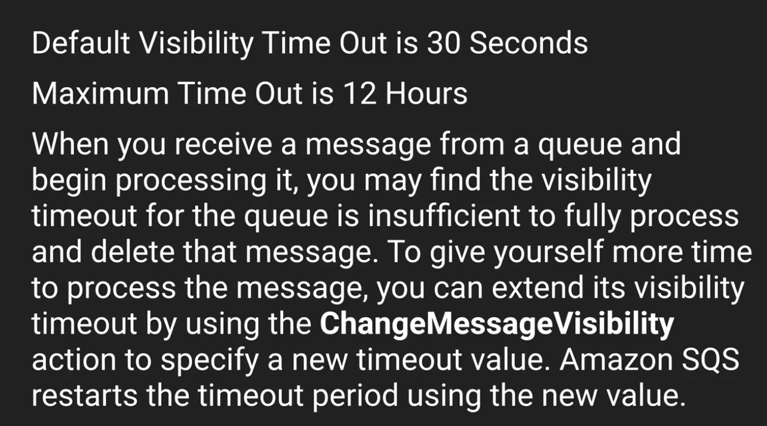 **ChangeMessageVisibility()**

**way to reduce polling when the queue is empty:**

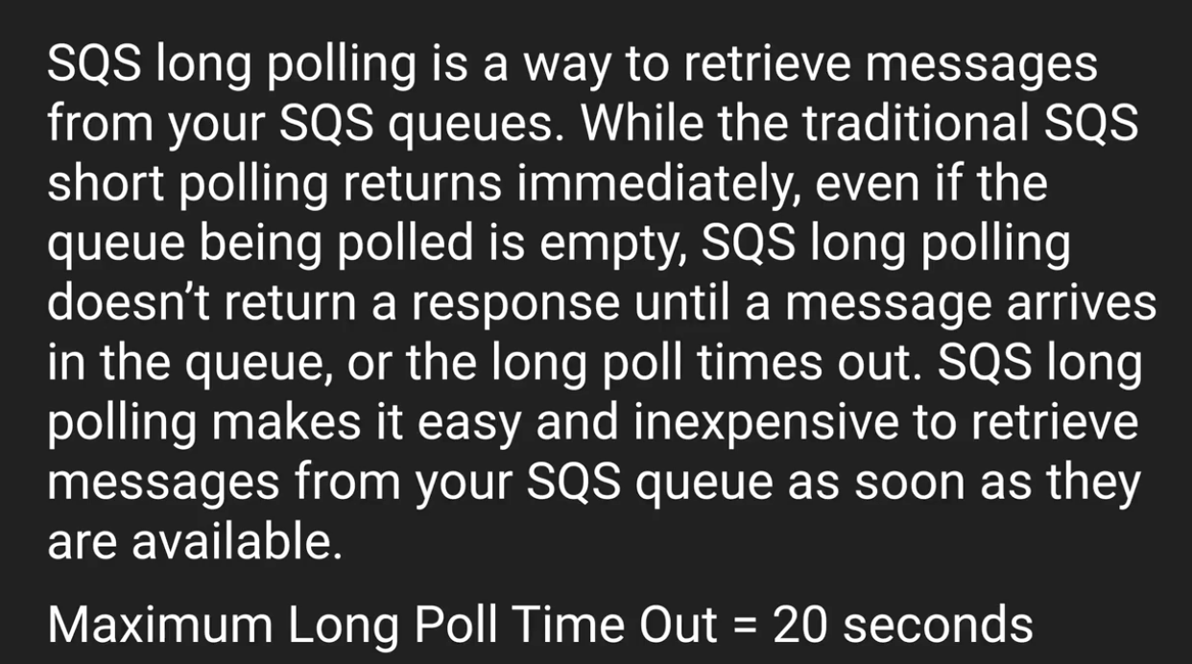

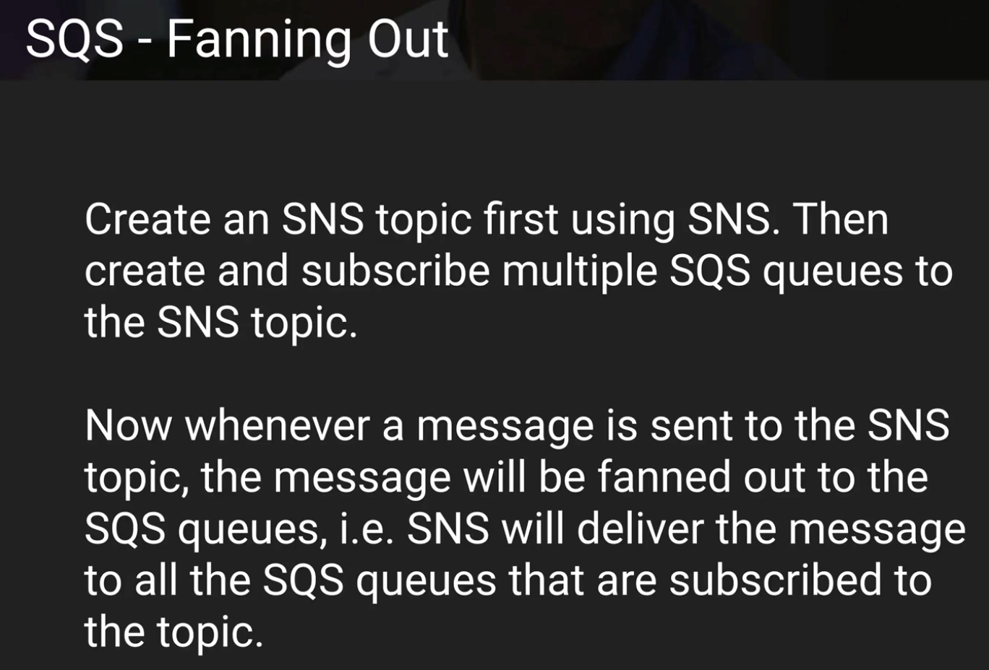

**You run a video-hosting website with two types of members: premium, fee-paying members; and free members. Each video that is uploaded is processed by a fleet of EC2 instances, which poll an SQS queue as videos are uploaded. However, you need to ensure that the videos uploaded by your premium, fee-paying members have a higher priority than those of your free members. How might you work with SQS to endure priority treatment of the premium members' videos?**

**Create two SQS queues — one for premium members, and one for free members. Program your EC2 fleet to poll the premium queue first and, if empty, to then poll your free members SQS queue.**

**Maximum retention period for a SQS message is :**

**14 days. Don’t get confused with visibility time out.**

**An SQS message can be delivered multiple times. – True**

**Which Amazon service can you use in conjunction with SQS to "fan out" SQS messages to multiple queues. - SNS**

**Simple Notification Service:**

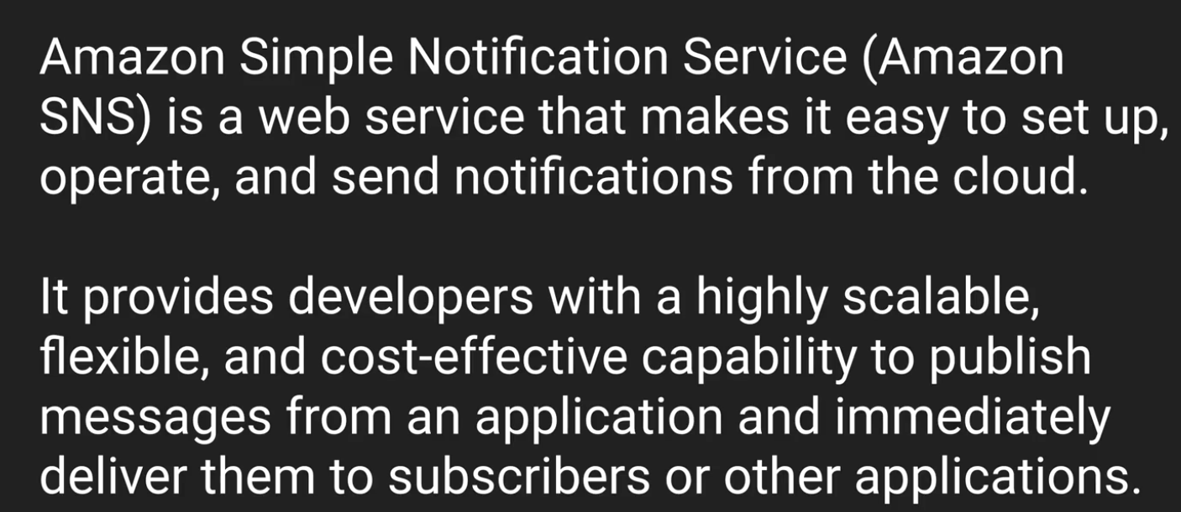

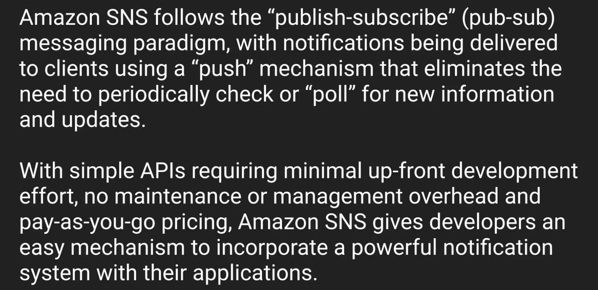

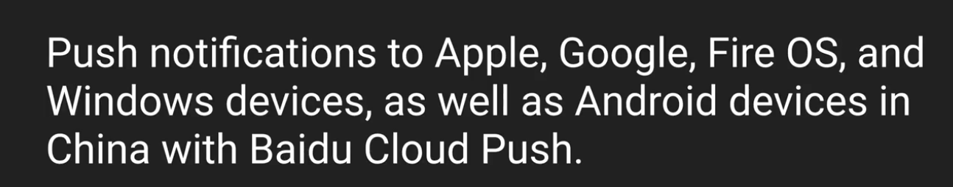

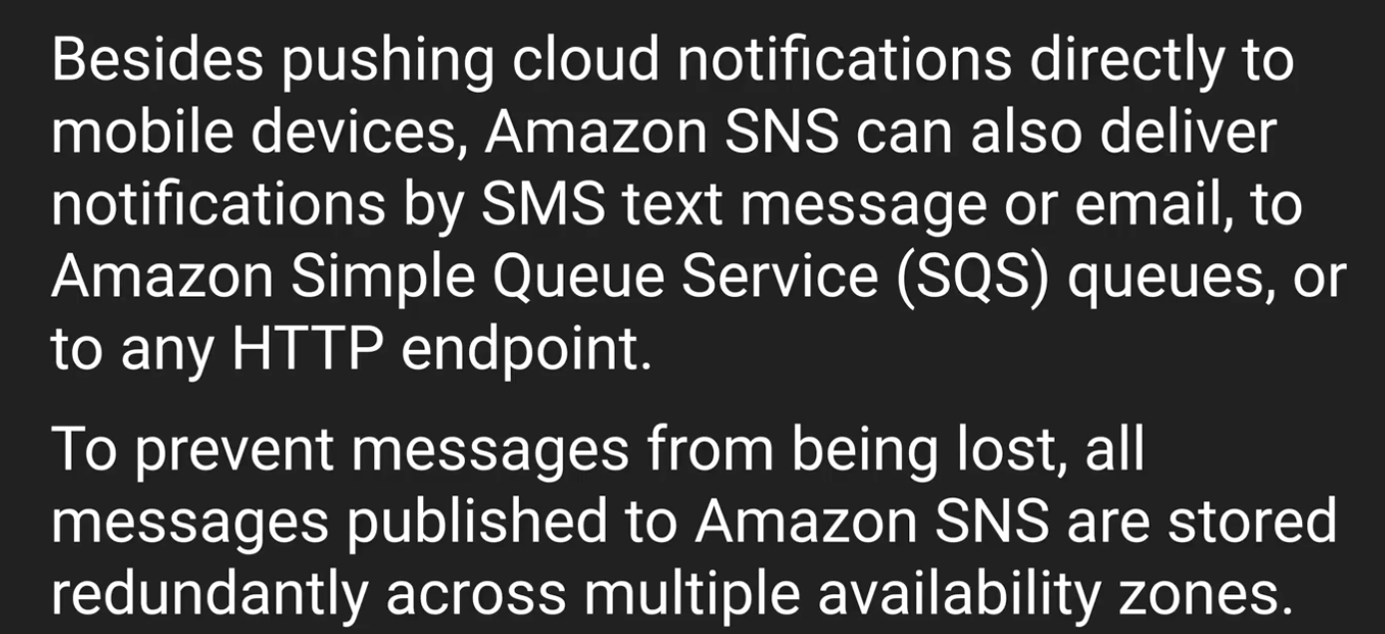

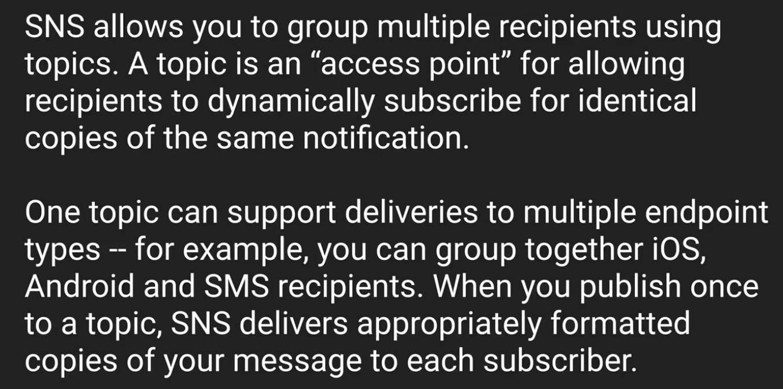

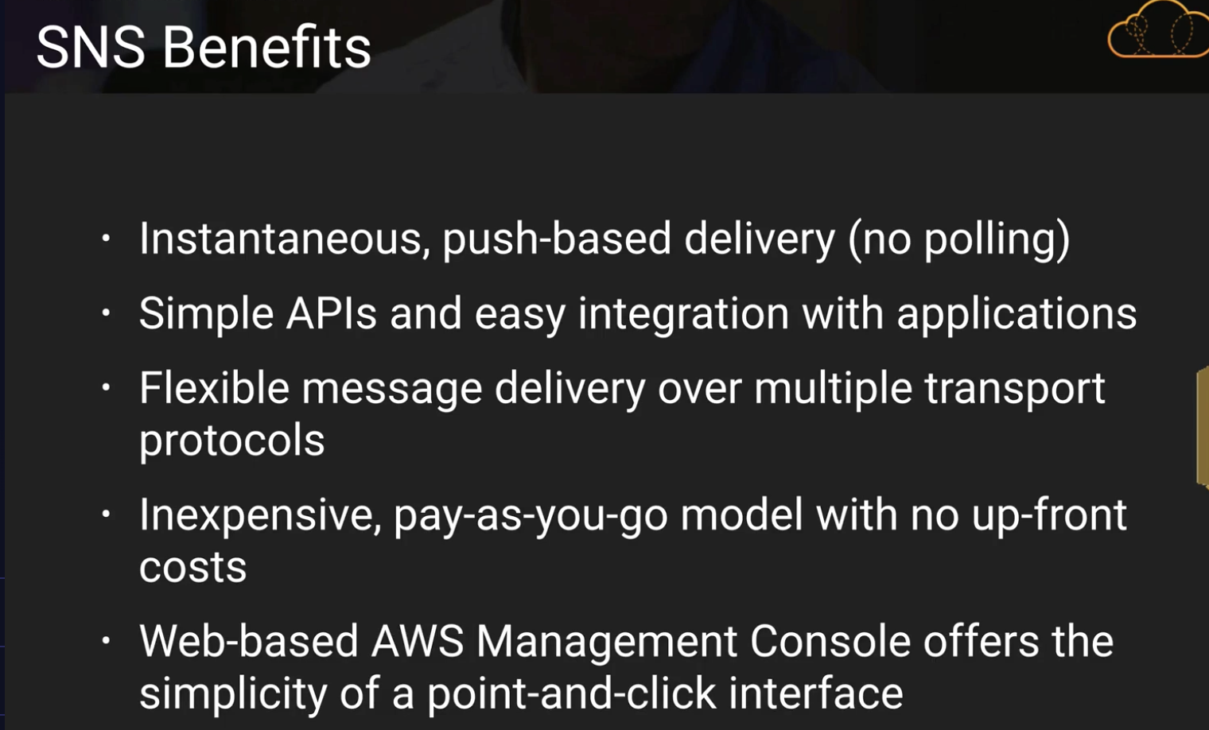

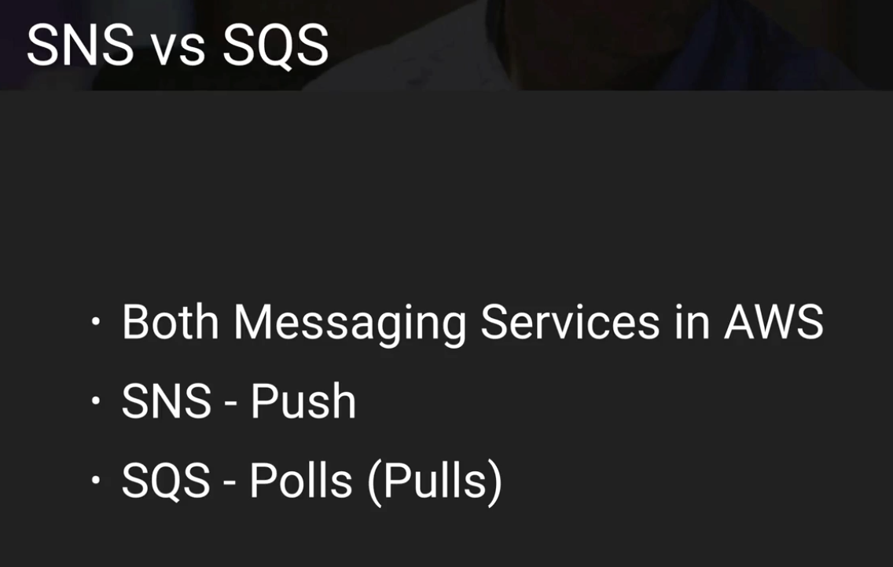

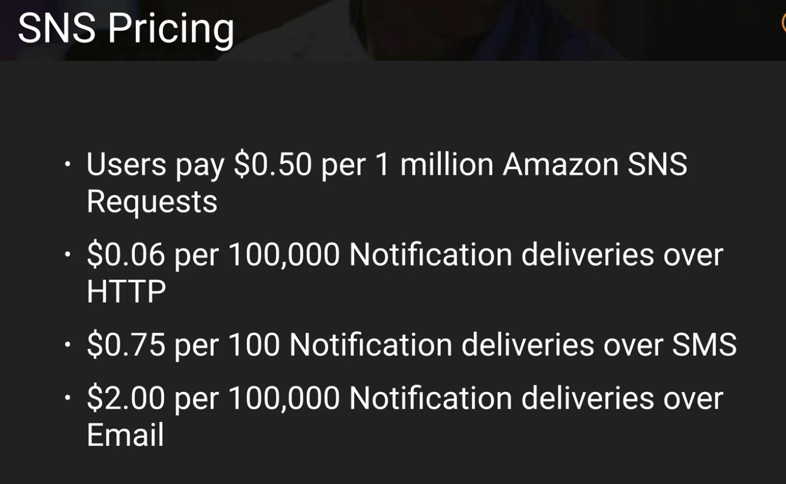

**data format of SNS is JSON**

**SNS Summary:**

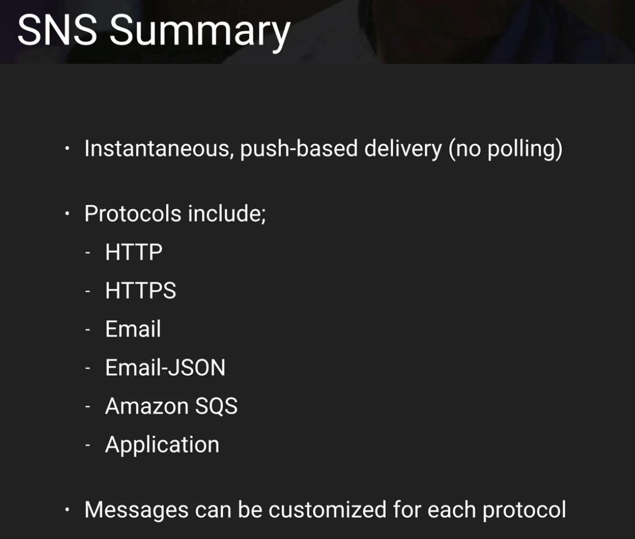

You have a list of email addresses to which you need to push emails on a periodic basis. What do you subscribe them to? – A TOPIC

SNS messages cannot be customized by protocol type. - False

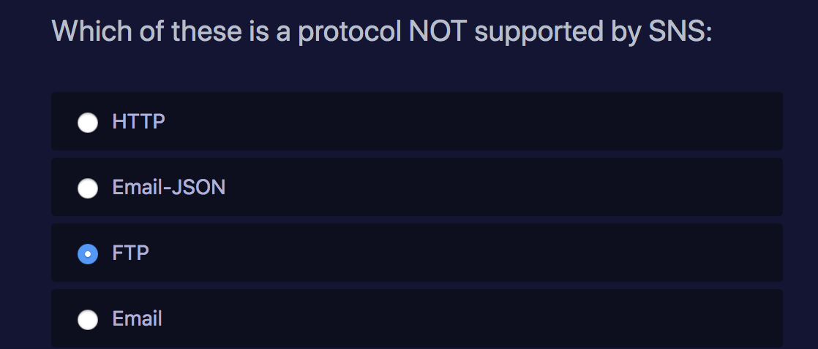

**Simple Work-Flow Service: (1 or 2 Questions) (tough questions)**

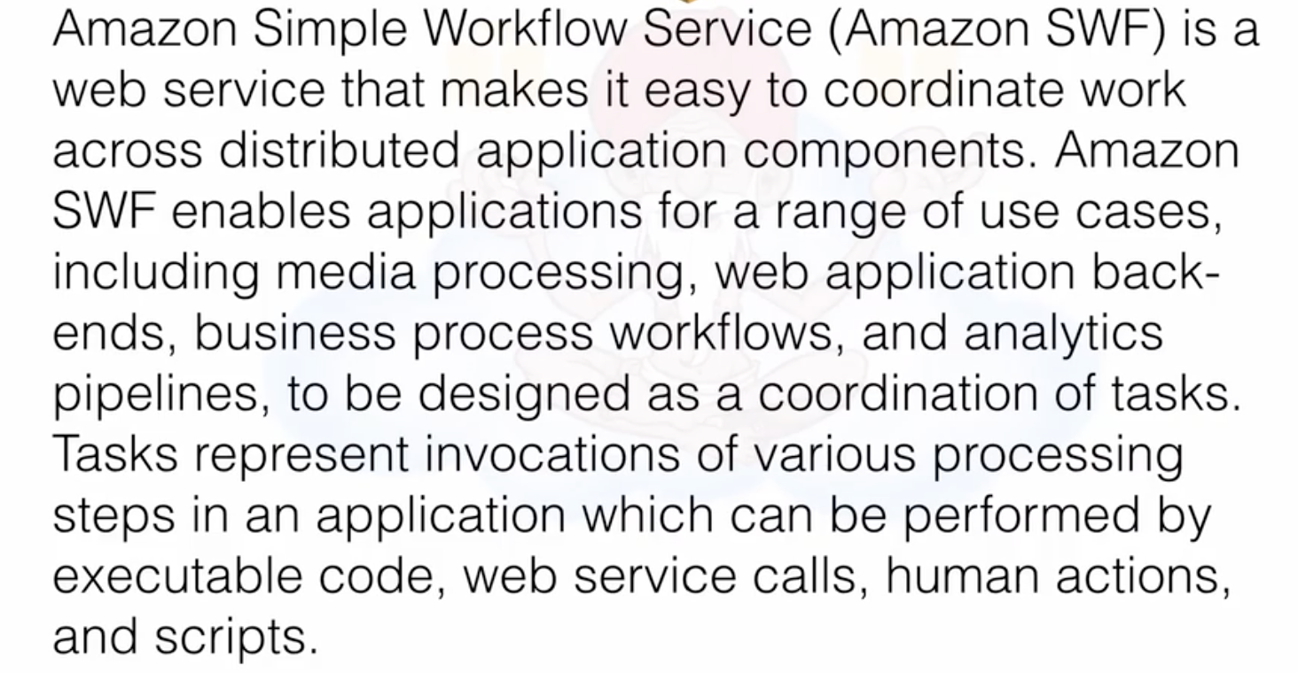

**Example:**

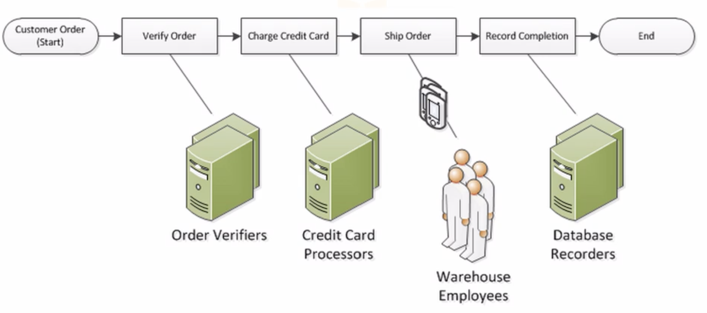

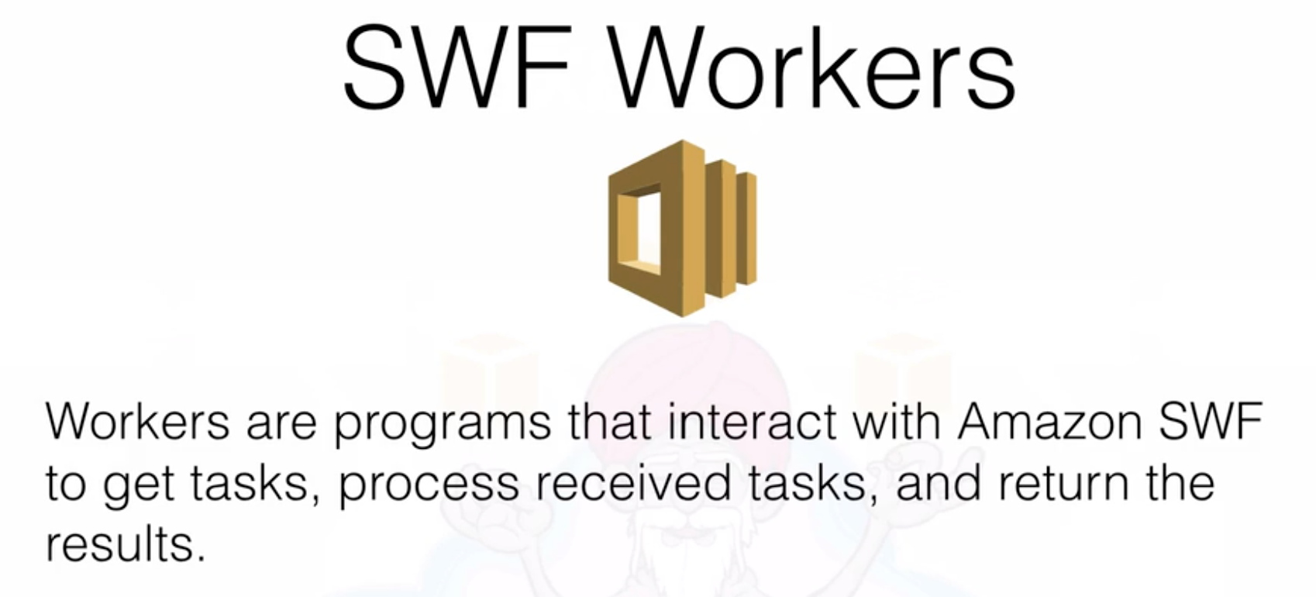

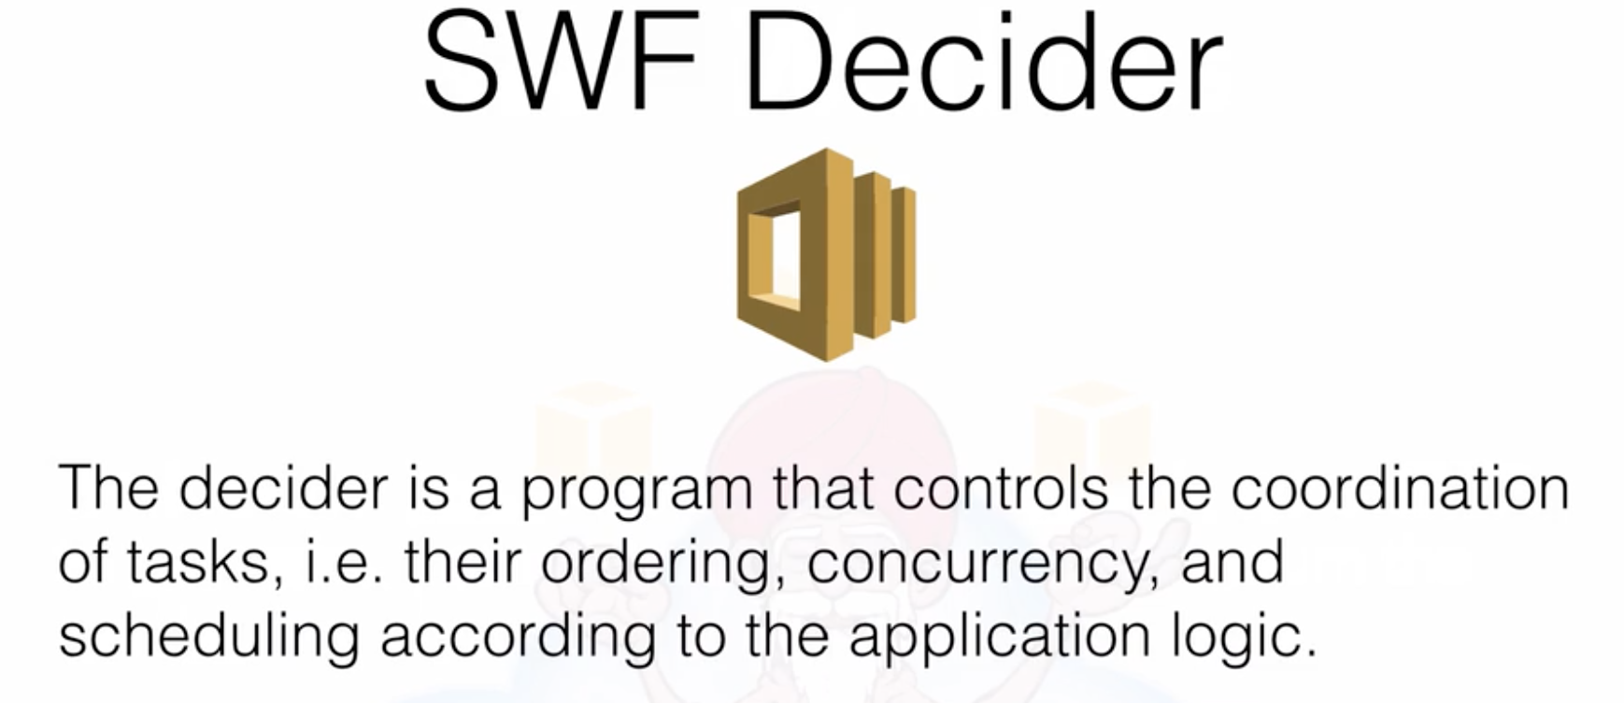

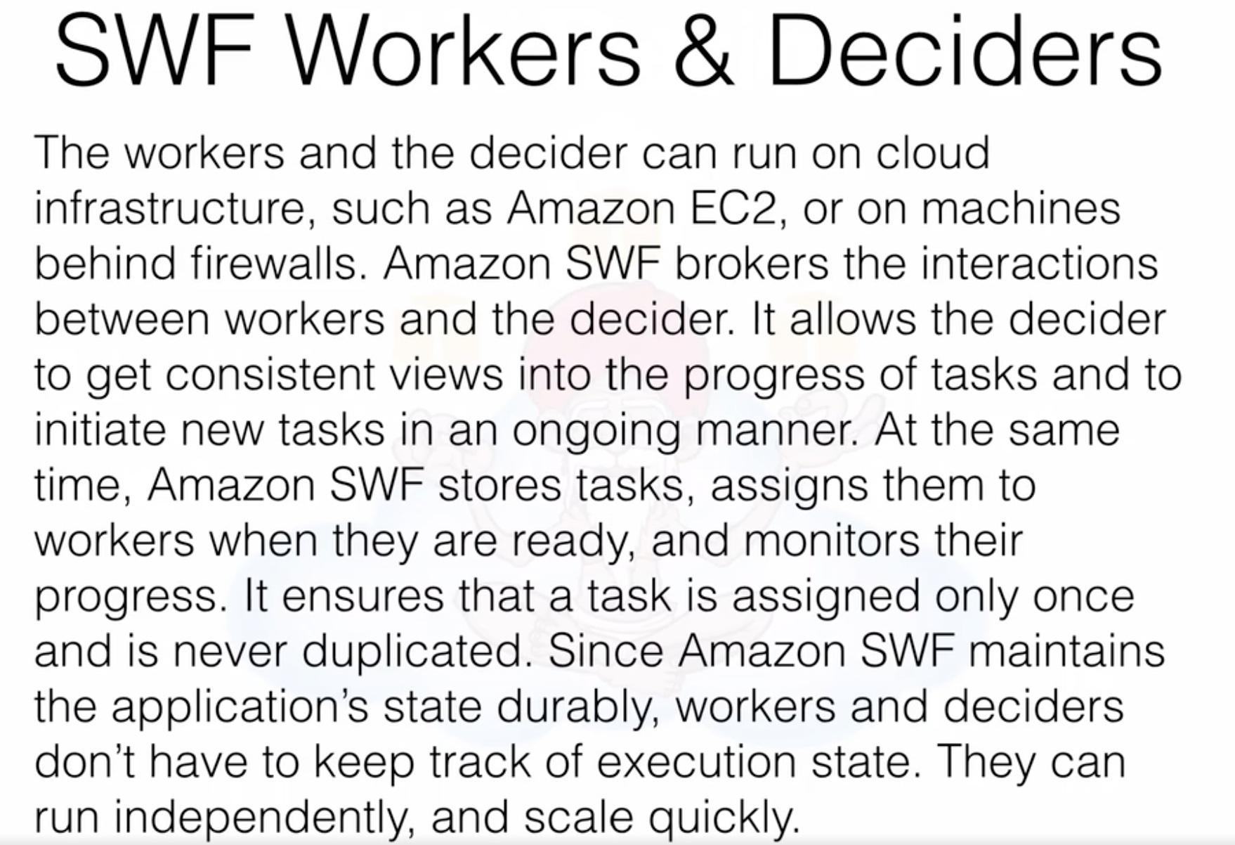

SWS – a task is only assigned once.

SQS – a task can be assigned multiple times (sometimes -if timed out)

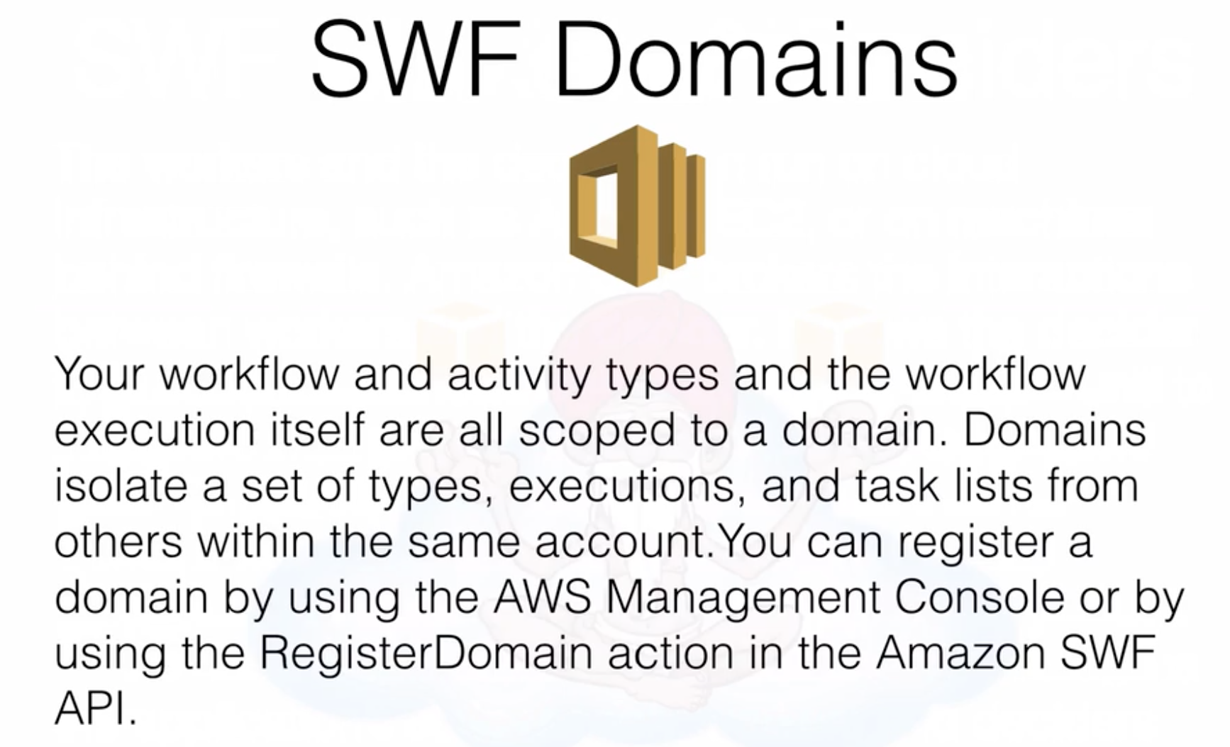

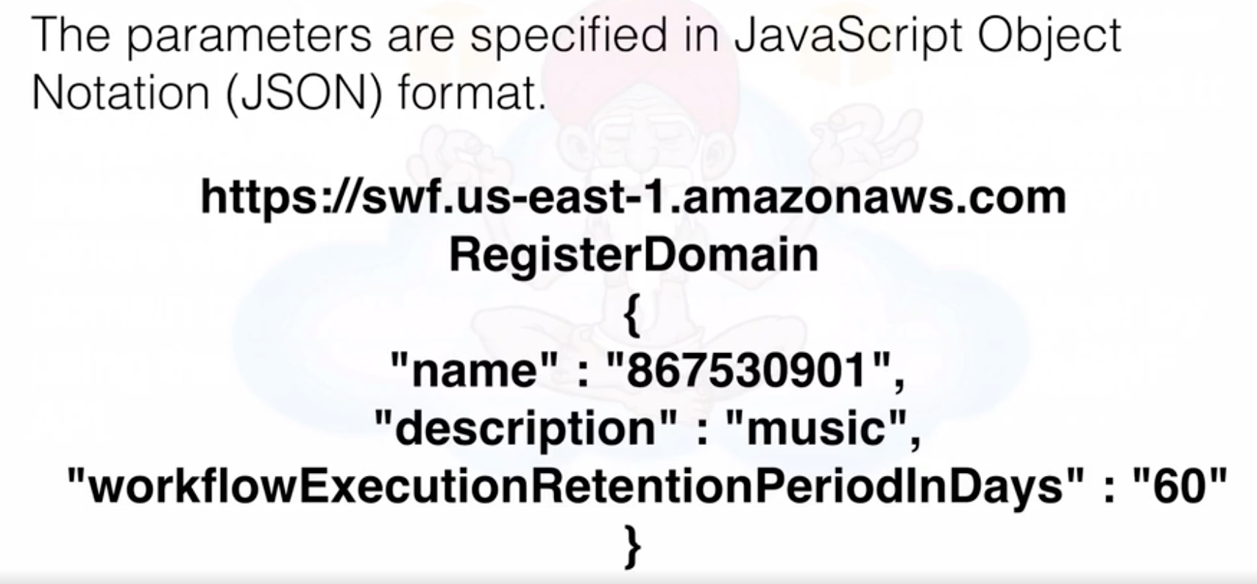

Compare between SQS and SWS: SQS max timeout is **12 hours while**

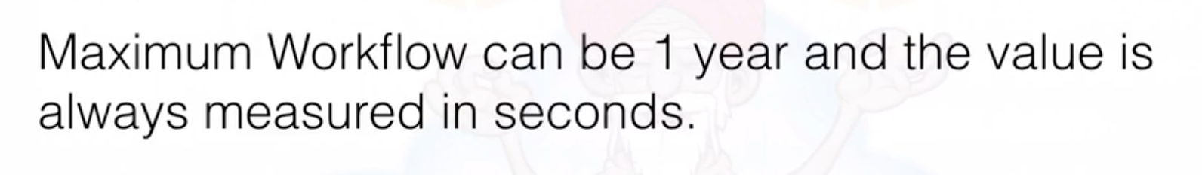

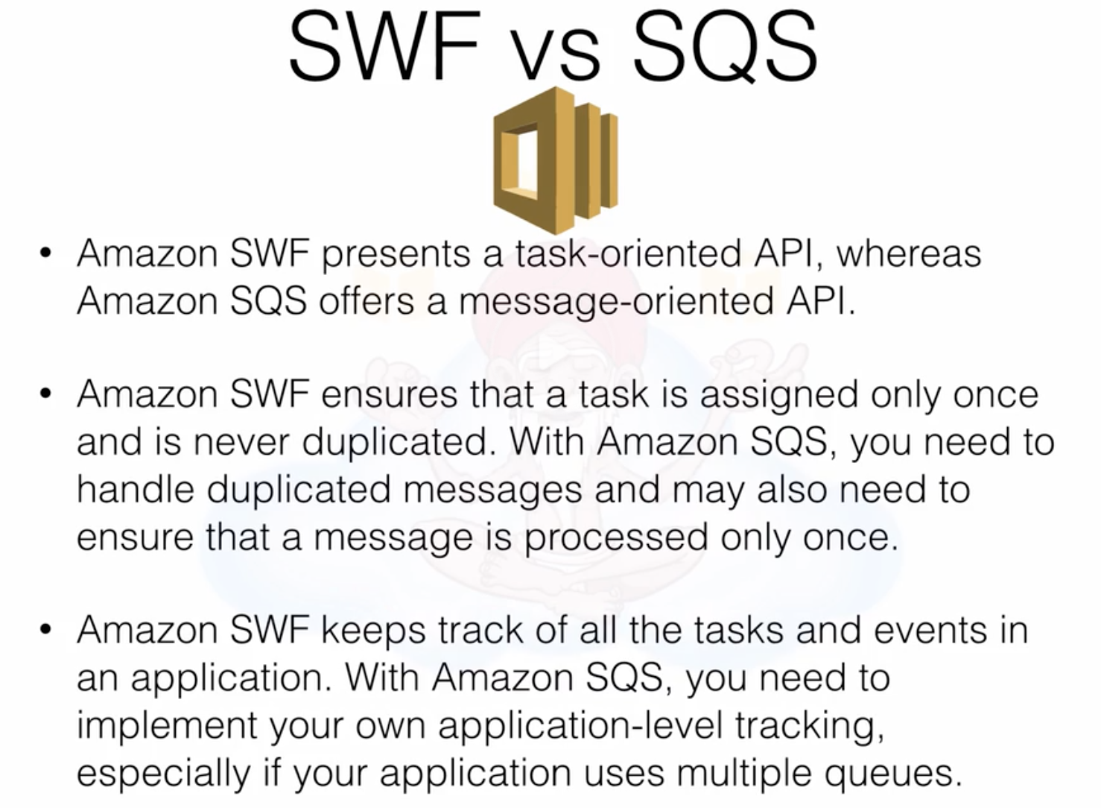

**Important Questions:**

**SWF consists of a domain, workers, and deciders. – True**

**what is a decider? - The decider is a program that controls the coordination of tasks, i.e. their ordering, concurrency, and scheduling according to the application logic.**

**Amazon SWF is useful for automating workflows that include long-running human tasks (e.g. approvals, reviews, investigations, etc.) Amazon SWF reliably tracks the status of processing steps that run up to several days or months. – True**

**what is a worker? - Workers are programs that interact with Amazon SWF to get tasks, process received tasks, and return the results.**

**Maintaining your application's execution state (e.g. which steps have completed, which ones are running, etc.) is a perfect use case for SWF. – TRUE**

**Elastic Beanstalk (4 to 5 Questions)**

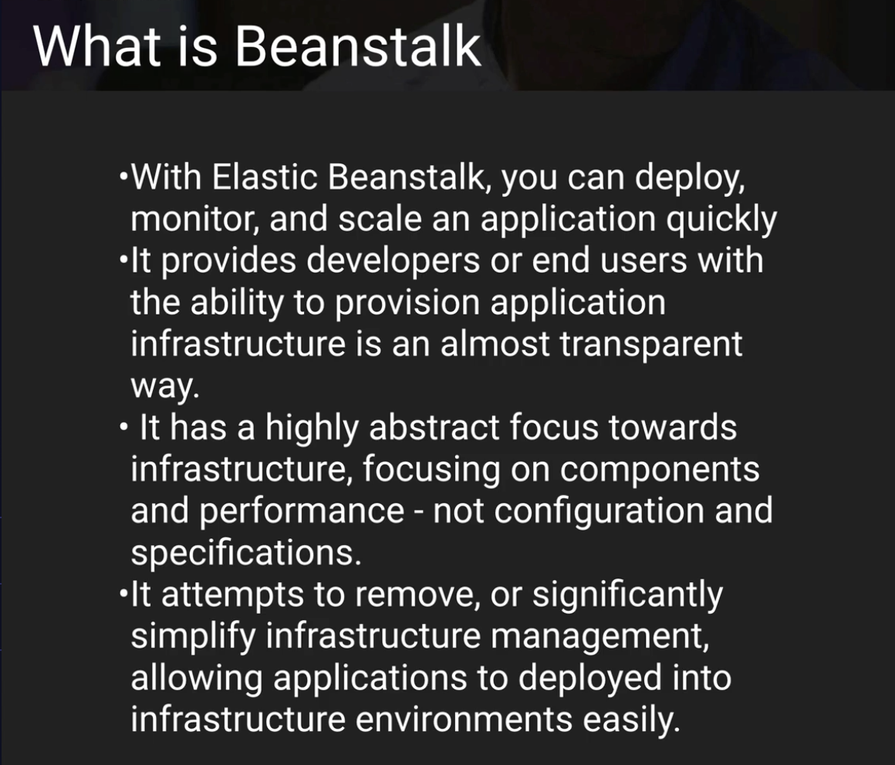

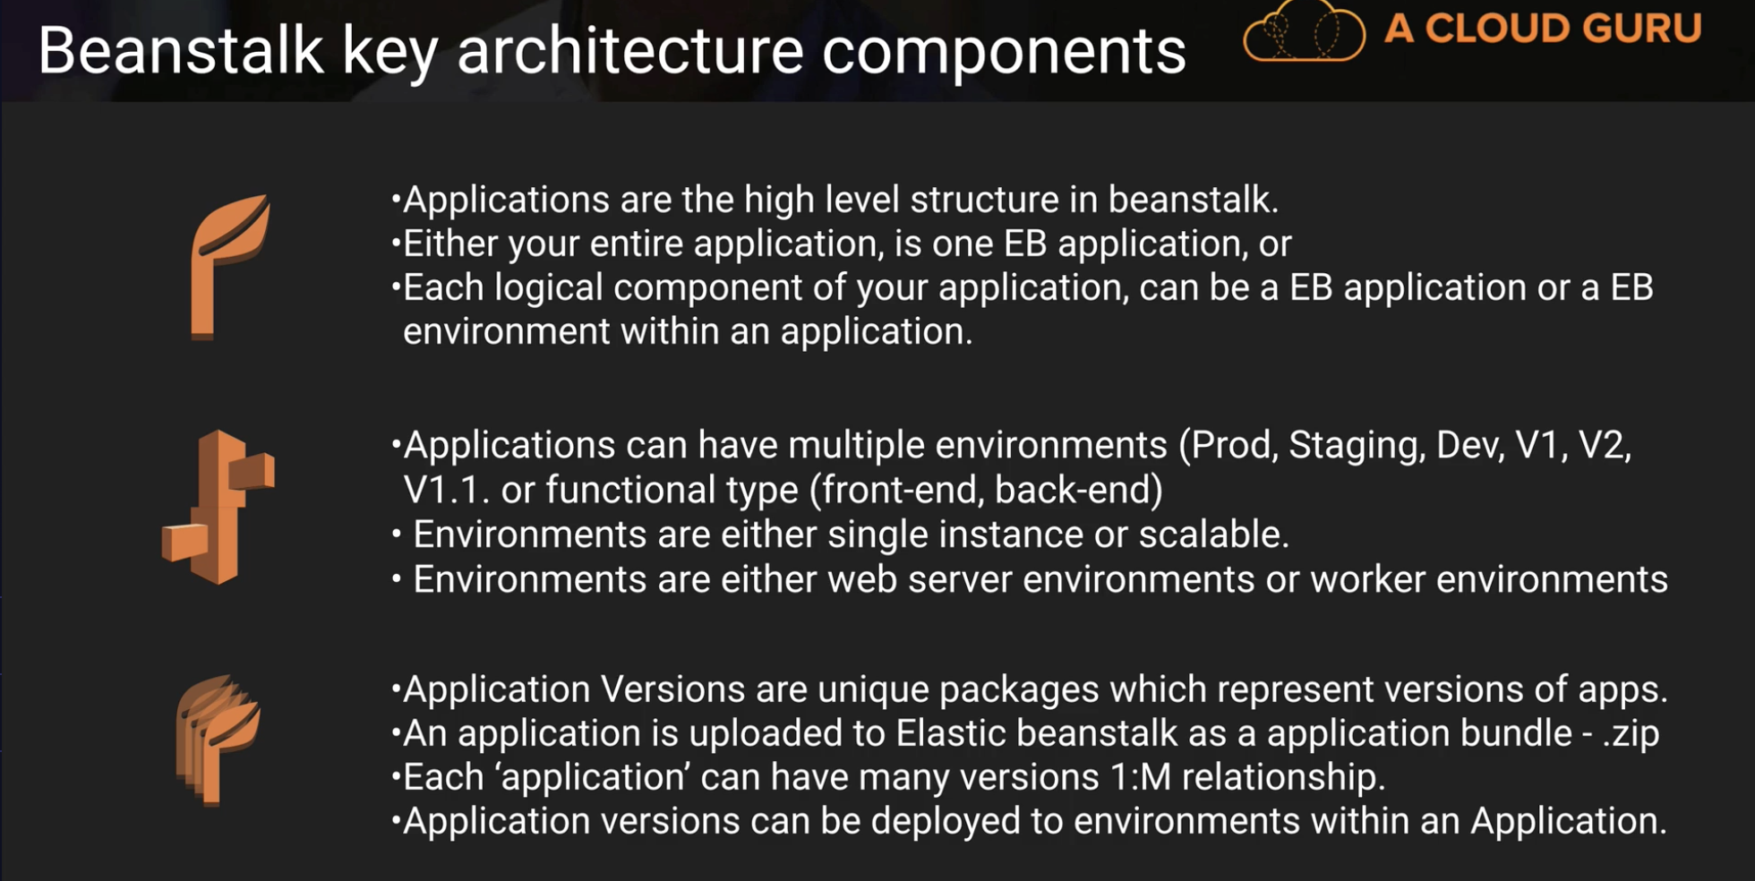

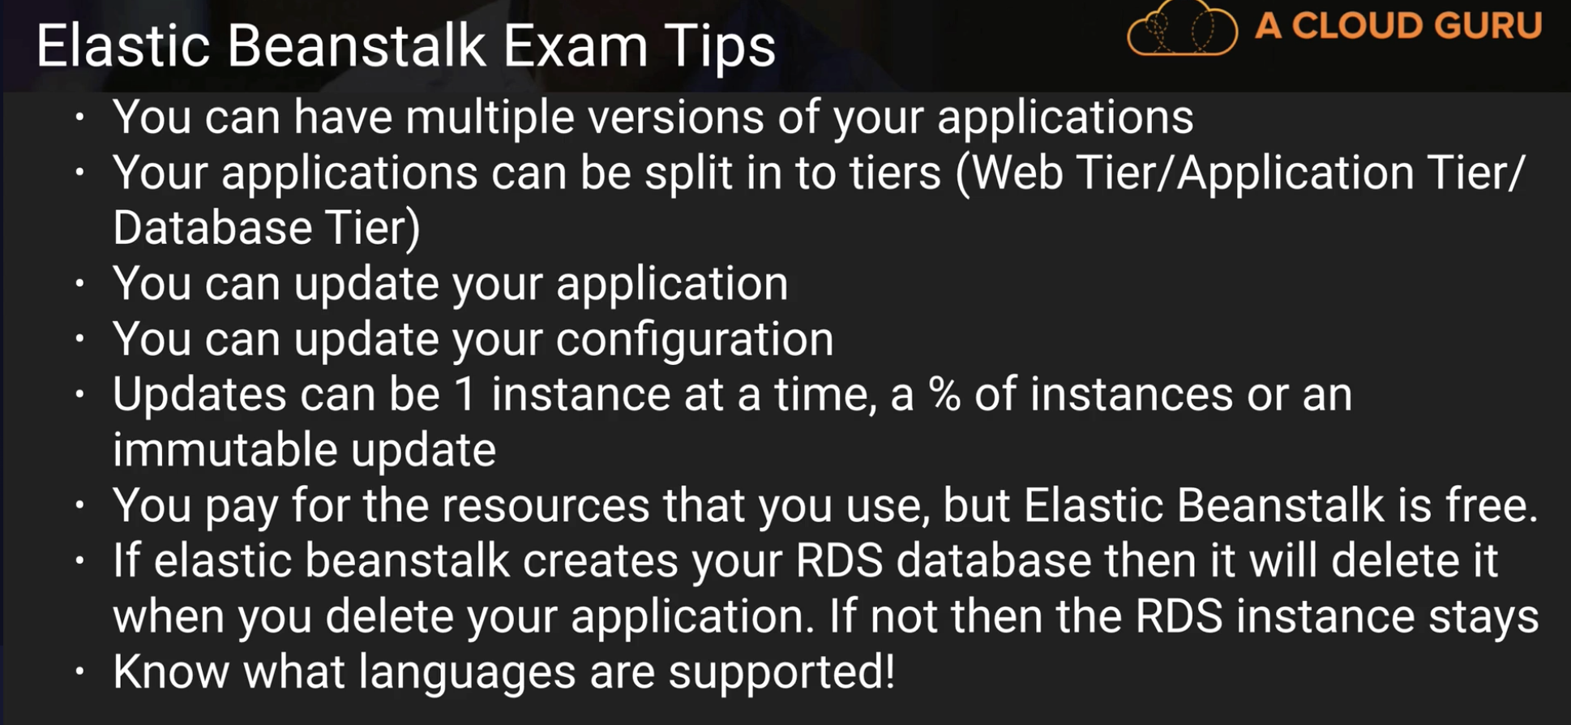

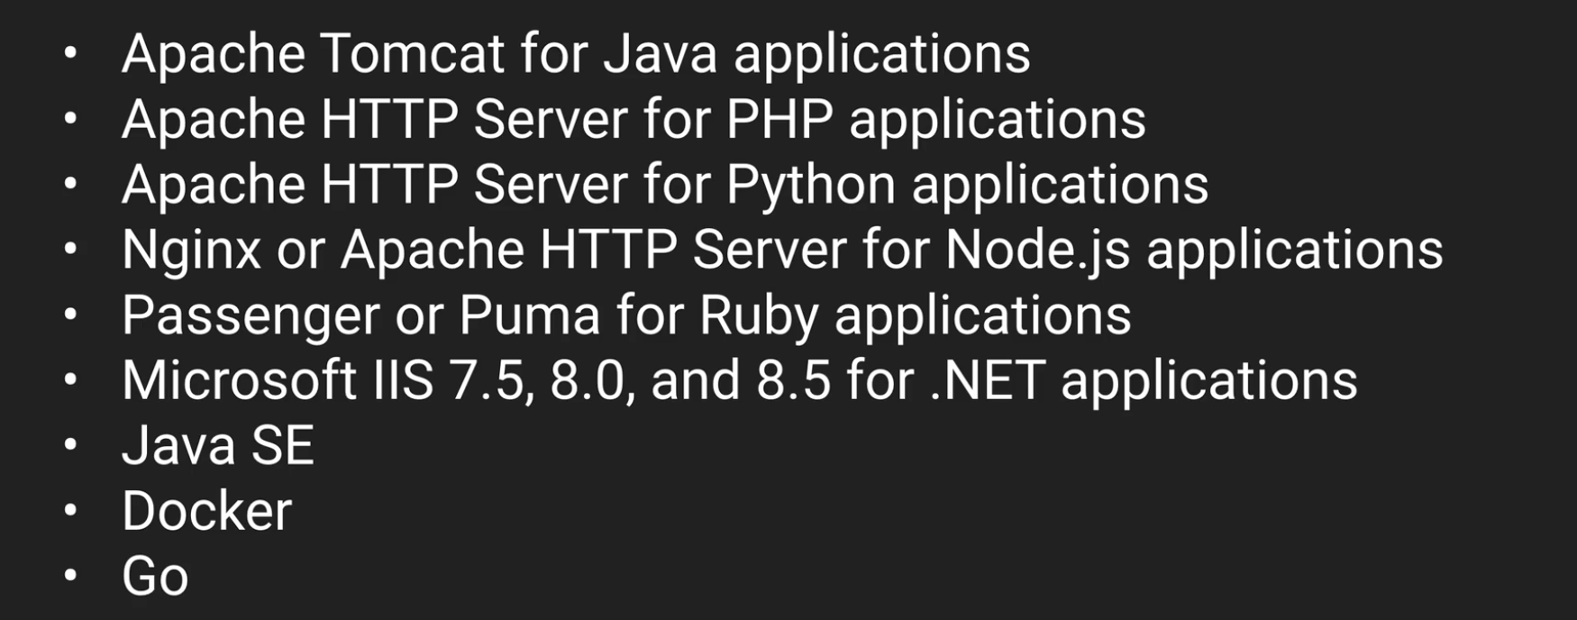

**Supporting env:**

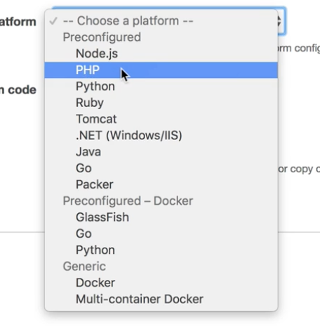

**Imp:**

**Elastic Beanstalk service itself is free. But resources tagged to it are not.**

**Elastic Beanstalk is object based storage – False**

**Cloud Formation (1 or 2 Questions)**

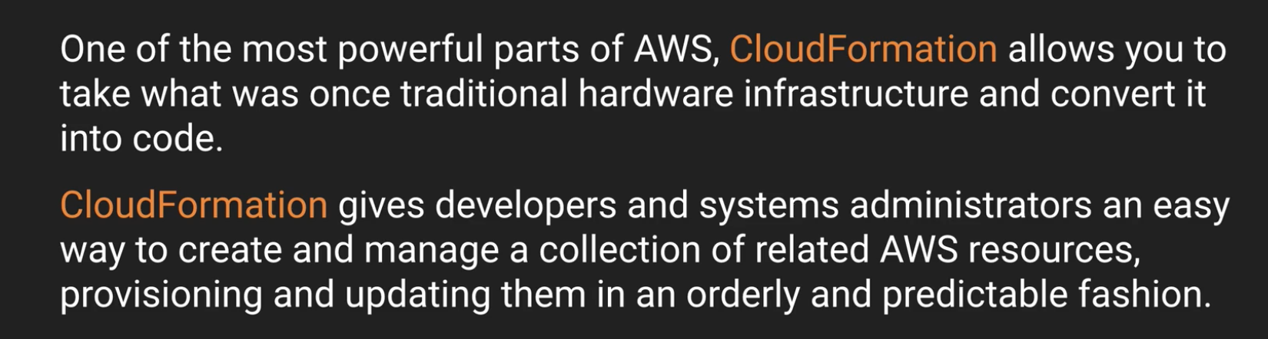

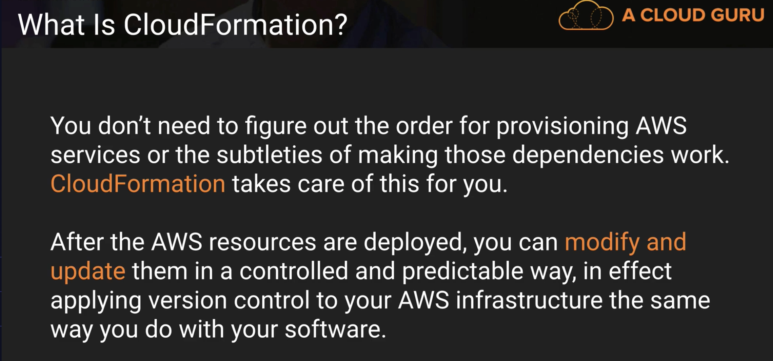

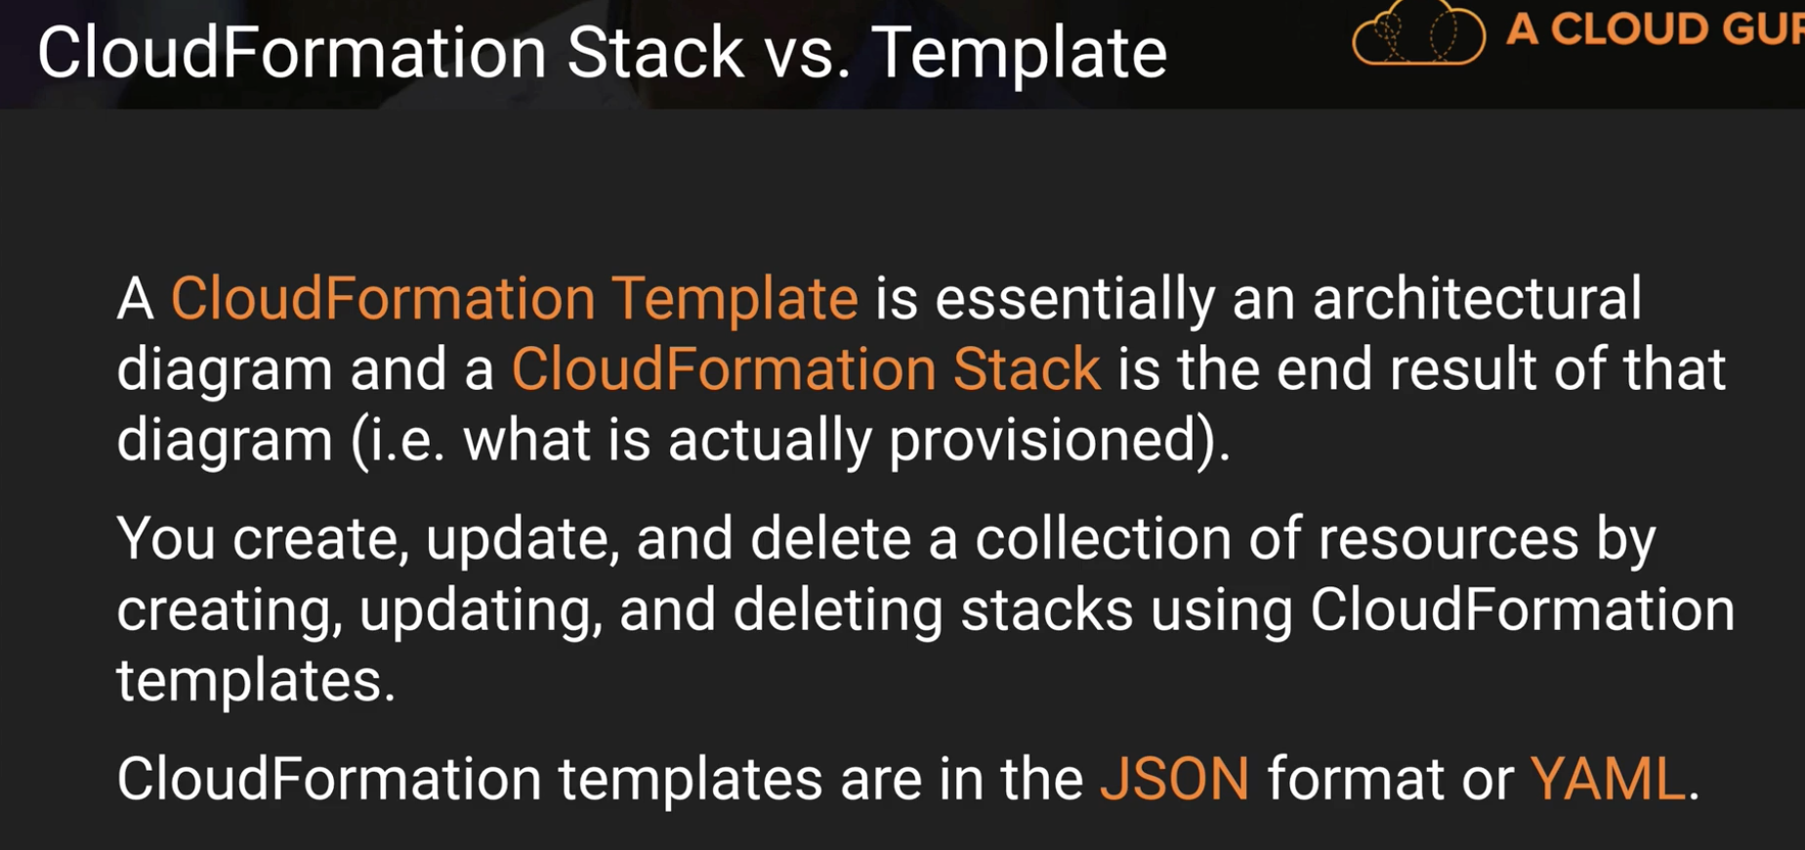

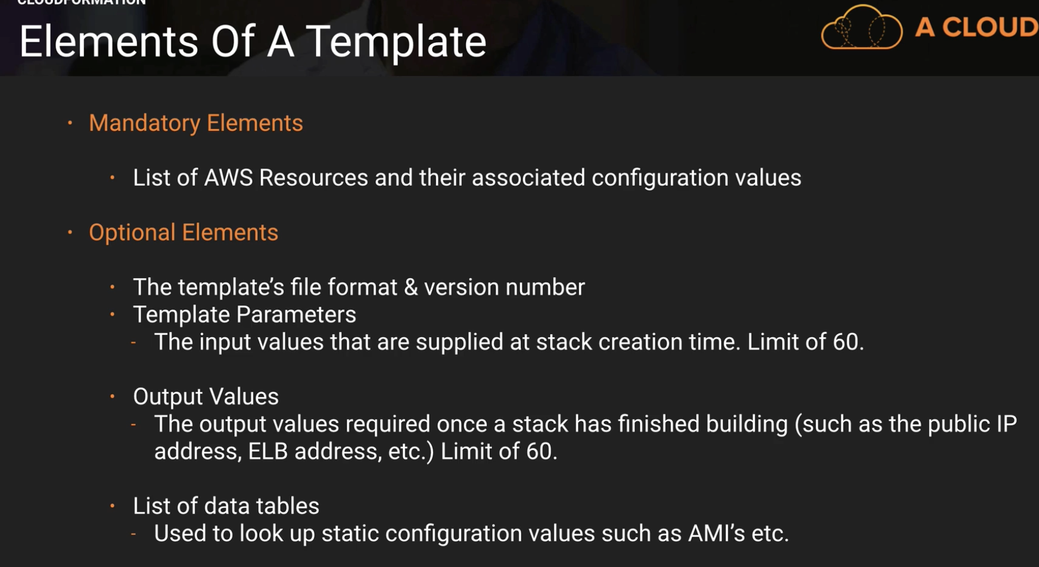

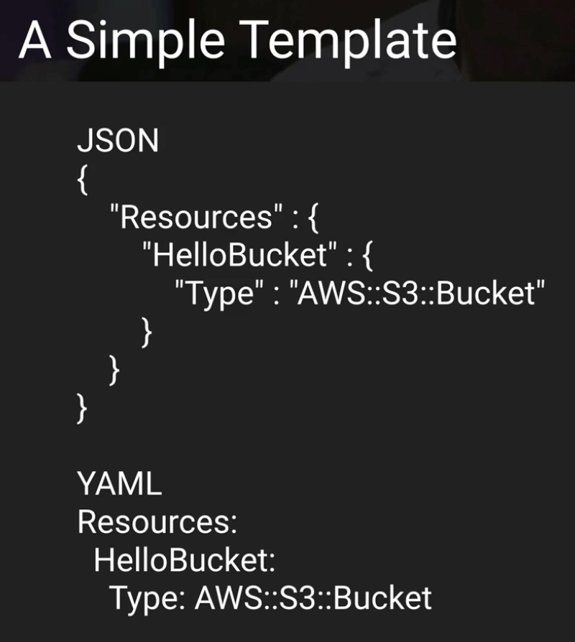

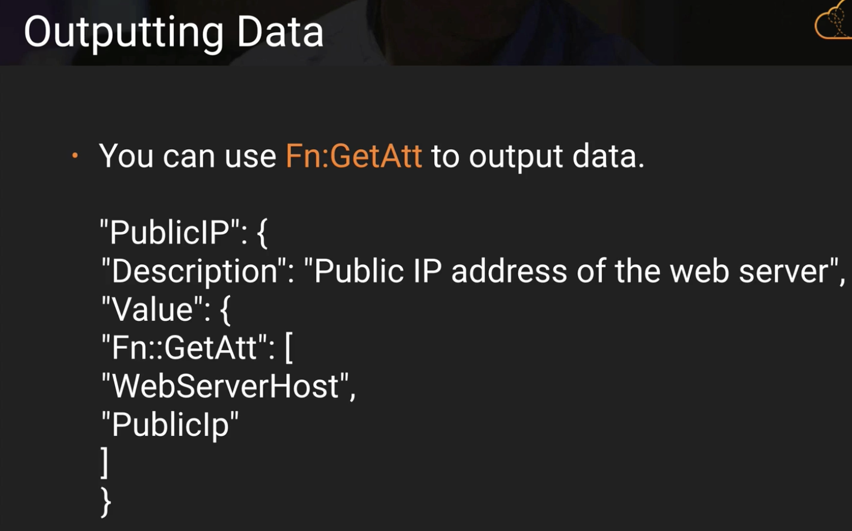 **(Fn:GetAtt)**

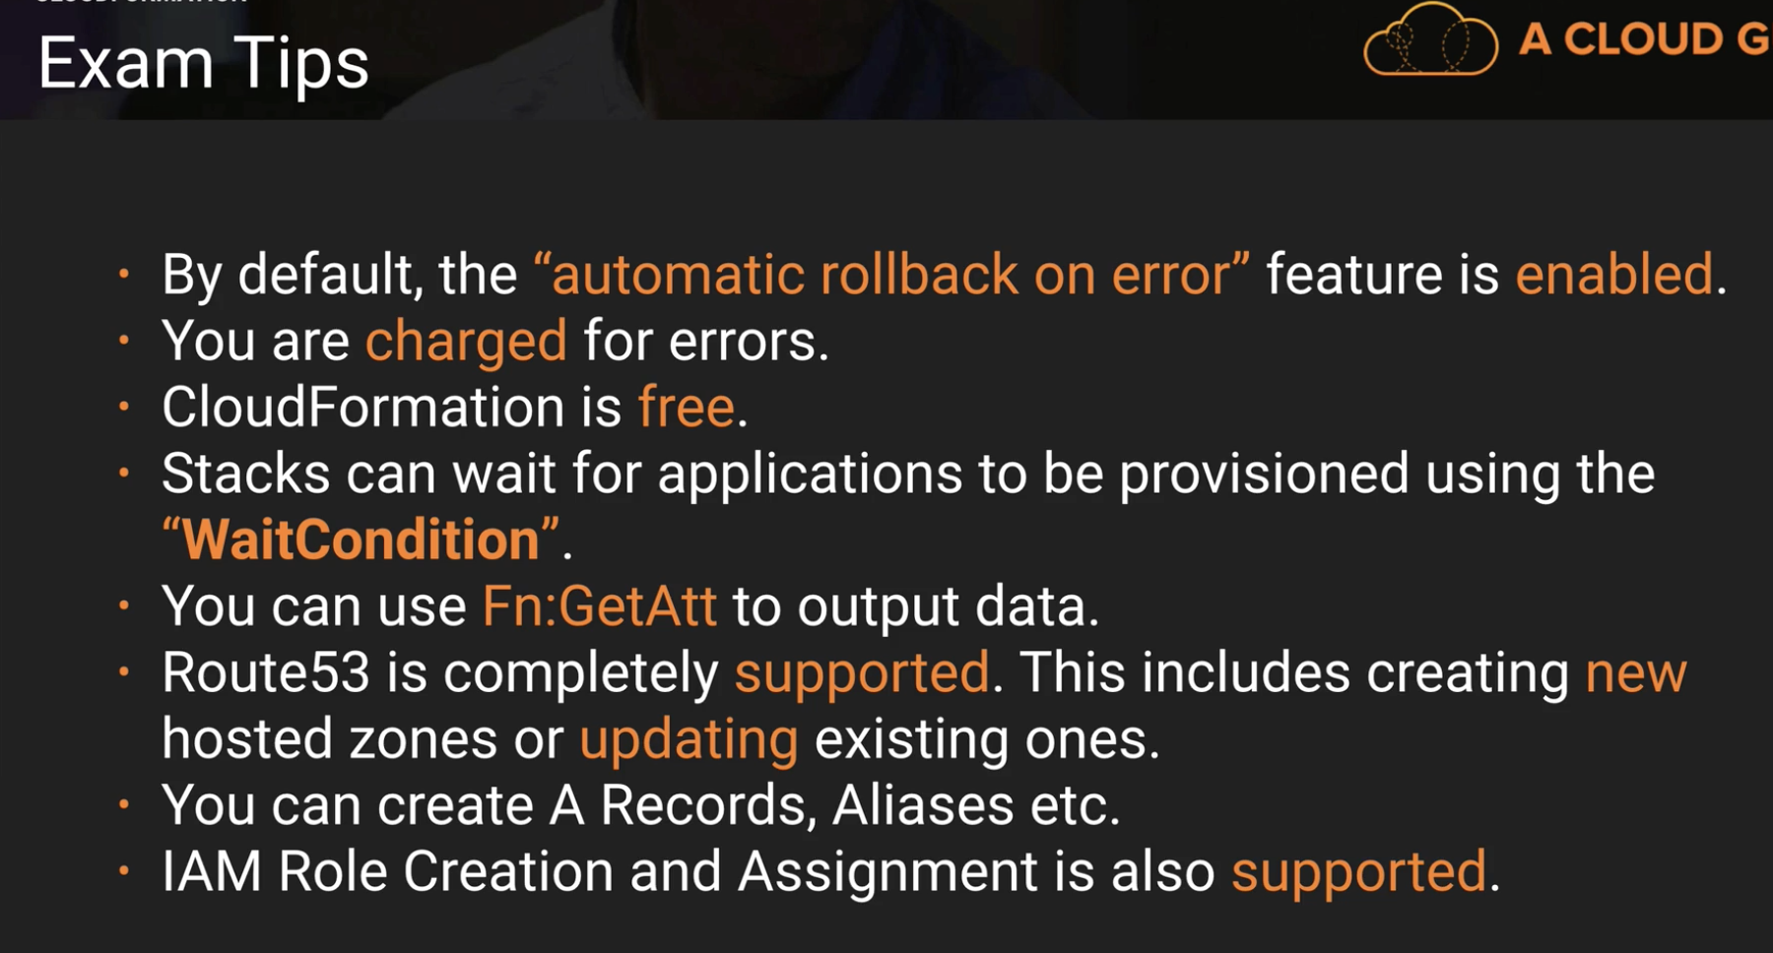

*Situation question: which one to use better in between Elastic beanstalk vs Cloud formation

**You are creating a virtual data centre using cloud formation and you need to output the DNS name of your load balancer. What command would you use to achieve this? - FN::GetAtt**

**By default, what happens if Cloud Formation encounters an error?**

**It will terminate and rollback all resources created on failure.**

**Cloud Formation itself is free, however the resources it provisions will be charged at the usual rates. – TRUE**

**The default scripting notation for Cloud Formation is JSON (can use YAML too)**

**AWS Shared Responsibility Model:**